AngularJS with SpringBoot
AngularJs is a Single page application. That means we have only index.html file, but we can change the views in single page.
Index.html
<body ng-app="">
….
<div ng-view="">
// we can change the views as per controller logic display view
</div>
….
<body>

SpringBoot App UI
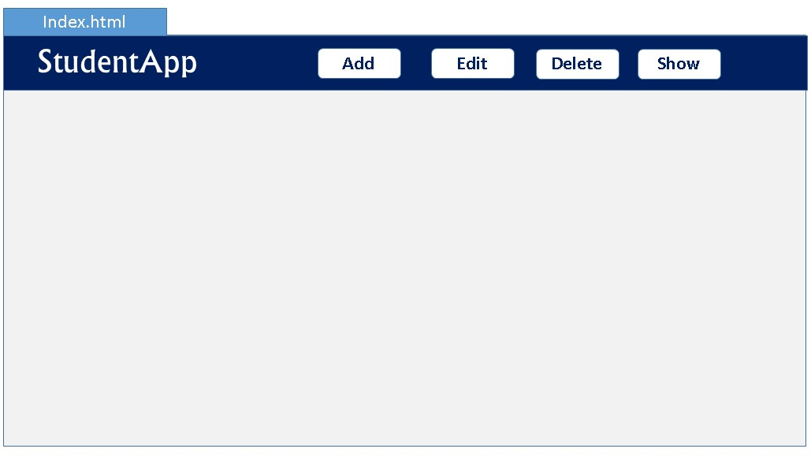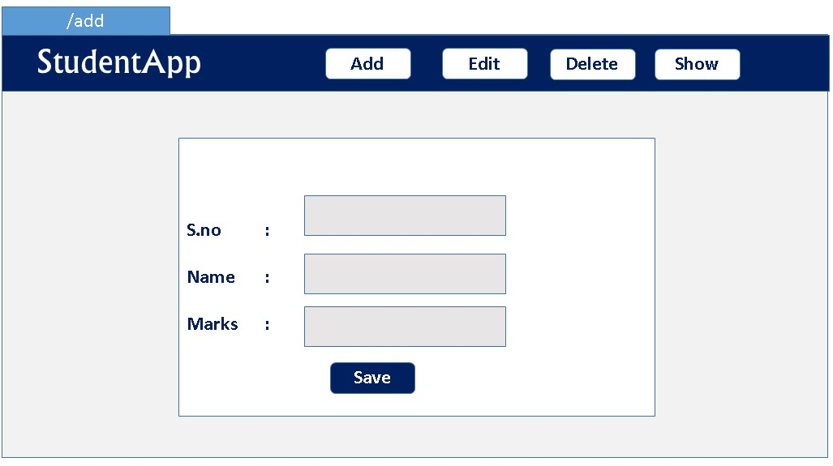
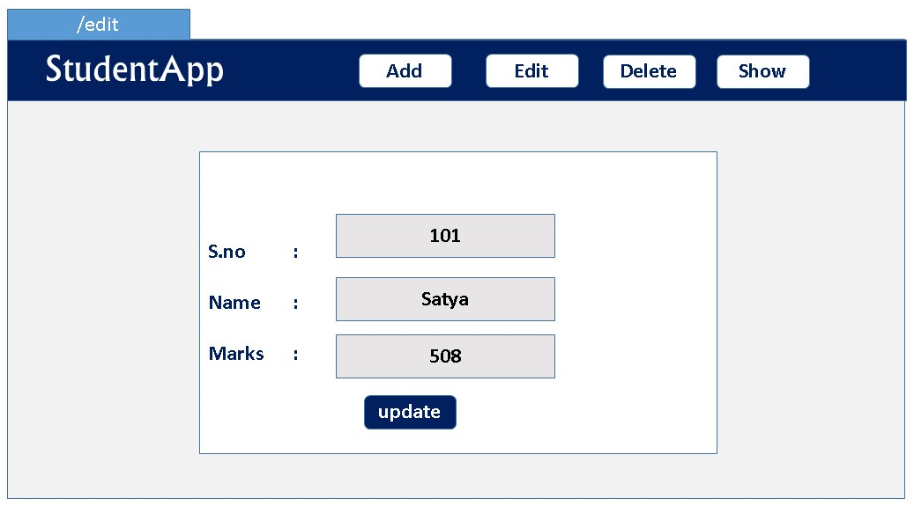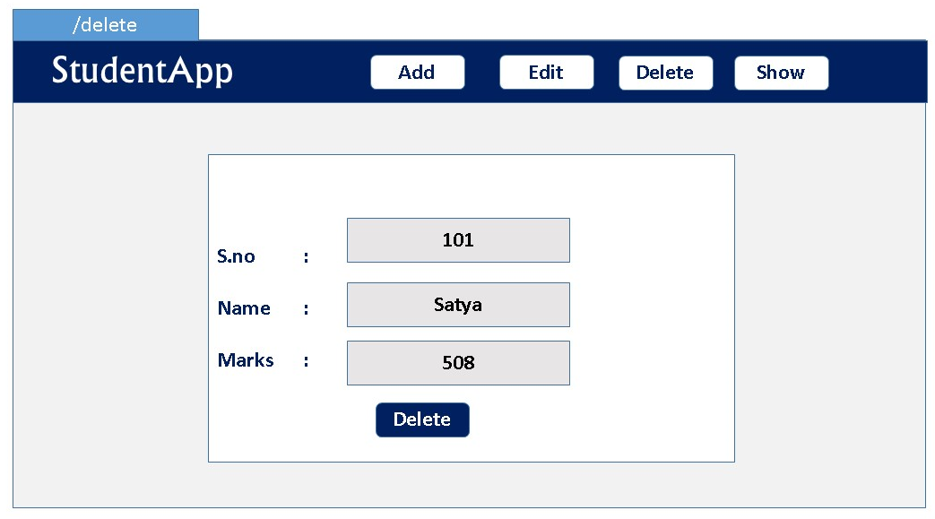

Before going to the implementation, we need to know Basics once.

Basics
AngularJS extends HTML attributes with Directives, and binds data to HTML with Expressions.
AngularJS is distributed as a JavaScript file, and can be added to a web page with a script tag:
<script src="https://ajax.googleapis.com/ajax/libs/angularjs/1.6.9/angular.min.js"></script>
- The ng-app directive defines an AngularJS application.
- The ng-model directive binds the value of HTML controls (input, select, textarea) to application data.
- The ng-bind directive binds application data to the HTML view
- {{ expression }}. expressions bind AngularJS data to HTML the same way as the ng-bind directive
<div ng-app="">
<p>Name: <input type="text" ng-model="name"></p>
<p ng-bind="name"></p>
<p>{{name}} </p> //will print the same
</div>

Understand with Example
AngularJS Example : index.html
<div ng-app="myApp" ng-controller="myCtrl">
First Name: <input type="text" ng-model="firstName"><br> //binds input with model
Last Name: <input type="text" ng-model="lastName"><br> ////binds input with model
Full Name: {{firstName + " " + lastName}} //Prints the model values
</div>
<script>
var app = angular.module('myApp', []);
app.controller('myCtrl', function($scope) {
$scope.firstName= "John";
$scope.lastName= "Doe";
});
</script>

1.ng-app
- The ng-app directive tells AngularJS that this is the root element of the AngularJS application.
- All AngularJS applications must have a root element.
- You can only have one ng-app directive in your HTML document. If more than one ng-app directive appears, the first appearance will be used
In index.html. We will have to tell Angular in which part of the application it should be active.
You saw that when declaring the angular module, we named it app. To tell it where it should be active we add the attribute ng-app="app" in the tag and everything inside of it turns into an AngularJS application.
In our case, as the whole page will be an ngapp it is better to place the attribute in the <html> tag or in the <body> tag.
only one AngularJS application can be auto-bootstrapped per HTML document. The first ngApp found in the document will be used to define the root element to auto-bootstrap as an application. To run multiple applications in an HTML document you must manually bootstrap them using angular.bootstrap instead.

2.ng-controller
The ngController directive specifies a Controller class; the class contains business logic behind the application to decorate the scope with functions and values.
In above 'myCtrl'has following business logic
app.controller('myCtrl', function($scope) {
$scope.firstName= "John";
$scope.lastName= "Doe";
});

3.angular.module
The angular.module is a global place for creating, registering and retrieving AngularJS modules. All modules (AngularJS core or 3rd party) that should be available to an application must be registered using this mechanism.
var app = angular.module('myApp', []);
in this line we registred the module with variable ‘app’. Now we can access this module in whole application with variable name to perform any kind of operations.
A module is a collection of services, directives, controllers, filters, and configuration information. angular.module is used to configure the $injector.
// Create a new module
var myModule = angular.module('myModule', []);

// register a new service
myModule.value('appName', 'MyCoolApp');

// configure existing services inside initialization blocks.
myModule.config(['$locationProvider', function($locationProvider) {
// Configure existing providers
$locationProvider.hashPrefix('!');
}]);

3.$scope
- $scope is a Global Object which can accessed by both view and controller.
- When adding properties to the $scope object in the controller, the view (HTML) gets access to these properties
- All applications have a $rootScope which is the scope created on the HTML element that contains the ng-app directive.
- The rootScope is available in the entire application.

AngularJs internal working
Now you will take a look at the architecture concepts of AngularJS. When an HTML document is loaded into the browser and is evaluated by the browser, the following happens:
- The AngularJS JavaScript file is loaded, and the Angular global object$scope is created. The JavaScript file that registers the controller functions is executed.

- AngularJS scans the HTML to look for AngularJS apps and views and finds a controller function corresponding to the view.

- AngularJS executes the controller functions and updates the views with data from the model populated by the controller.

- AngularJS listens for browser events, such as button clicked, mouse moved, input field being changed, and so on. If any of these events happen, then AngularJS will update the view accordingly
Bootstrapping AngularJS by Adding ng-app in an HTML Page
<html lang="en" ng-app="userregistrationsystem">...</html>
This is also known as automatic initialization. So, when AngularJS finds the ng-app directive after analyzing the index.html file, it loads the associated modules and then compiles the DOM.

Few More Examples
AngularJS Example : ng-init, {{ expression }} = ng-bind
<div ng-app="" ng-init="firstName='John';lastName='Doe'">
<p>The name is {{ firstName + " " + lastName }}</p>
<p>The name is <span ng-bind="firstName + ' ' + lastName"></span></p>
</div>

AngularJS Objects
AngularJS objects are like JavaScript objects:
<div ng-app="" ng-init="person={firstName:'John',lastName:'Doe'}">
<p>The name is {{ person.lastName }}</p> //or
<p>The name is <span ng-bind="person.lastName"></span></p>
</div>

AngularJS Arrays
AngularJS arrays are like JavaScript arrays:
<div ng-app="" ng-init="points=[1,15,19,2,40]">
<p>The third result is {{ points[2] }}</p>
</div>

AngularJS Module
- Creating a Module
<div ng-app="myApp">...</div>
<script>
var app = angular.module("myApp", []);
</script>

- Adding a Controller
<script>
var app = angular.module("myApp", []);
app.controller("myCtrl", function($scope) {
$scope.firstName = "John";
$scope.lastName = "Doe";
});
</script>

AngularJs Validation
The ng-model directive can provide type validation for application data (number, e-mail, required):
<form ng-app="" name="myForm">
Email:
<input type="email" name="myAddress" ng-model="text">
<span ng-show="myForm.myAddress.$error.email">Not a valid e-mail address</span>
</form>

AngularJs Controllers – with Different Data
- Inside another function
<script>
var app = angular.module('myApp', []);
app.controller('personCtrl', function($scope) {
$scope.firstName = "John";
$scope.lastName = "Doe";
$scope.fullName = function() {
return $scope.firstName + " " + $scope.lastName;
};
});
</script>
- With Array data
File : namesController.js
angular.module('myApp', []).controller('namesCtrl', function($scope) {
$scope.names = [
{name:'Jani',country:'Norway'},
{name:'Hege',country:'Sweden'},
{name:'Kai',country:'Denmark'}
];
});

<div ng-app="myApp" ng-controller="namesCtrl">
<ul>
<li ng-repeat="x in names">
{{ x.name + ', ' + x.country }}
</li>
</ul>
</div>
<script src="namesController.js"></script>

AngularJS Filters
AngularJS provides filters to transform data:
- uppercase Format a string to upper case.
<p>The name is {{ lastName | uppercase }}</p>

- lowercase Format a string to lower case.
<p>The name is {{ lastName | lowercase }}</p>

- currency Format a number to a currency format.
<h1>Price: {{ price | currency }}</h1> //output is : Price: $58.00

- filter Select a subset of items from an array.
This example displays only the names containing the letter "i".
<ul>
<li ng-repeat="x in names | filter : 'i'">
{{ x }}
</li>
</ul>

- orderBy Orders an array by an expression.
<ul>
<li ng-repeat="x in names | orderBy:'country'">
{{ x.name + ', ' + x.country }}
</li>
</ul>
- json Format an object to a JSON string.
- date Format a date to a specified format.
- number Format a number to a string.
- limitTo Limits an array/string, into a specified number of elements/characters.

AngularJS Services
- In AngularJS, a service is a function, or object, that is available for your AngularJS application.
- AngularJS has about 30 built-in services. One of them is the $location service.
1.$location
returns information about the location of the current web page:
var app = angular.module('myApp', []);
app.controller('customersCtrl', function($scope, $location) {
$scope.myUrl = $location.absUrl();
});
{{myUrl}} //prints https://www.w3schools.com/angular/tryit.asp?filename=try_ng_services

$2.$http
$http is an AngularJS service for reading data from remote servers. The AngularJS $http service makes a request to the server, and returns a response.
var app = angular.module('myApp', []);
app.controller('myCtrl', function($scope, $http) {
$http.get("welcome.htm").then(function (response) {
$scope.myWelcome = response.data;
});
});

More on Http
The example above uses the .get method of the $http service.
The .get method is a shortcut method of the $http service. There are several shortcut methods:
- .get()
- .post()
- .put()
- .delete()
- .head()
- .jsonp()
- .patch()
var app = angular.module('myApp', []);
app.controller('myCtrl', function($scope, $http) {
$http({
method : "GET",
url : "welcome.htm"
}).then(function mySuccess(response) {
$scope.myWelcome = response.data;
}, function myError(response) {
$scope.myWelcome = response.statusText;
});
});

Responnse Types
- .config the object used to generate the request.
- .data a string, or an object, carrying the response from the server.
- .headers a function to use to get header information.
- .status a number defining the HTTP status.
- .statusText a string defining the HTTP status.
<div ng-app="myApp" ng-controller="myCtrl">
<p>Data : {{content}}</p>
<p>Status : {{statuscode}}</p>
<p>StatusText : {{statustext}}</p>
</div>
var app = angular.module('myApp', []);
app.controller('myCtrl', function($scope, $http) {
$http.get("welcome.htm")
.then(function(response) {
$scope.content = response.data;
$scope.statuscode = response.status;
$scope.statustext = response.statusText;
});
});
Data : Hello AngularJS Students
Status : 200
StatusText :

$timeout
The $timeout service is AngularJS' version of the window.setTimeout function.
var app = angular.module('myApp', []);
app.controller('myCtrl', function($scope, $timeout) {
$scope.myHeader = "Hello World!";
$timeout(function () {
$scope.myHeader = "How are you today?";
}, 2000);
});

AngularJs DOM Elements
Like in JavaScript we can hide,show,disable DOM elements
<button disabled>Click Me!</button> //to Disable button

- Hide/show
<p ng-show="true">I am visible.</p>
<p ng-show="false">I am not visible.</p>
<p ng-hide="true">I am not visible.</p>
<p ng-hide="false">I am visible.</p>

AngularJS Events
You can add AngularJS event listeners to your HTML elements by using one or more of these directives:
- ng-blur
- ng-change
- ng-click
- ng-copy
- ng-cut
- ng-dblclick
- ng-focus
- ng-keydown
- ng-keypress
- ng-keyup
- ng-mousedown
- ng-mouseenter
- ng-mouseleave
- ng-mousemove
- ng-mouseover
- ng-mouseup
- ng-paste

Increase the count variable when the mouse clicked.
<div ng-app="myApp" ng-controller="myCtrl">
<button ng-click="count = count + 1">Click me!</button>
<p>{{ count }}</p>
</div>
//At Start count is 0 once Js load
<script>
var app = angular.module('myApp', []);
app.controller('myCtrl', function($scope) {
$scope.count = 0;
});
</script>

Same, replace with function call
<div ng-app="myApp" ng-controller="myCtrl">
<button ng-click="myFunction()">Click me!</button>
<p>{{ count }}</p>
</div>
<script>
var app = angular.module('myApp', []);
app.controller('myCtrl', function($scope) {
$scope.count = 0;
$scope.myFunction = function() {
$scope.count++;
}
});
</script>

AngularJS Includes
With ng-include directive, you can include HTML from an external file.
<div ng-include="'myFile.htm'"></div>

AngularJS Routing
The ngRoute module helps your application to become a Single Page Application.
- If you want to navigate to different pages in your application, but you also want the application to be a SPA (Single Page Application), with no page reloading, you can use the ngRoute module.

- The ngRoute module routes your application to different pages without reloading the entire application.

For doing this
- you must include the AngularJS Route module JS
<script src="https://ajax.googleapis.com/angular-route.js"></script>

- Then you must add the ngRoute as a dependency in the application module:
var app = angular.module("myApp", ["ngRoute"]);

- Now your application has access to the route module, which provides the $routeProvider. Use the $routeProvider to configure(app.config) different routes in your application:
app.config(function($routeProvider) {
$routeProvider
.when("/", {
templateUrl : "main.htm"
})
.when("/red", {
templateUrl : "red.htm"
})
.when("/green", {
templateUrl : "green.htm"
})
.when("/blue", {
templateUrl : "blue.htm"
});
});

Example

<body ng-app="myApp">
<a href="#/!">Main</a></p>
<a href="#!red">Red</a>
<a href="#!green">Green</a>
<a href="#!blue">Blue</a>
<div ng-view>
<! —HERE CONTENT CHANGES -->
</div>
<script>
var app = angular.module("myApp", ["ngRoute"]);
app.config(function($routeProvider) {
$routeProvider
.when("/", {
templateUrl : "main.htm"
})
.when("/red", {
templateUrl : "red.htm"
})
.when("/green", {
templateUrl : "green.htm"
})
.when("/blue", {
templateUrl : "blue.htm"
});
});
</script>
</body>

1.ng-view
Your application needs a container to put the content provided by the routing.This container is the ng-view directive. There are three different ways to include the ng-view directive in your application:
- <div ng-view></div>
- <div class="ng-view"></div>
- <ng-view></ng-view>
Applications can only have one ng-view directive, and this will be the placeholder for all views provided by the route.

2.routeProvider
With the $routeProvider you can also define a controller for each "view".
var app = angular.module("myApp", ["ngRoute"]);
app.config(function($routeProvider) {
$routeProvider
.when("/", {
templateUrl : "main.htm"
})
.when("/london", {
templateUrl : "london.htm",
controller : "londonCtrl"
})
.when("/paris", {
templateUrl : "paris.htm",
controller : "parisCtrl"
});
});
app.controller("londonCtrl", function ($scope) {
$scope.msg = "I love London";
});
app.controller("parisCtrl", function ($scope) {
$scope.msg = "I love Paris";
});

3.template
In the previous examples we have used the templateUrl property in the $routeProvider.when method. You can also use the template property, which allows you to write HTML directly in the property value, and not refer to a page.
var app = angular.module("myApp", ["ngRoute"]);
app.config(function($routeProvider) {
$routeProvider
.when("/", {
template : "<h1>Main</h1><p>Click on the links to change this content</p>"
})
.when("/banana", {
template : "<h1>Banana</h1><p>Bananas contain around 75% water.</p>"
})
.when("/tomato", {
template : "<h1>Tomato</h1><p>Tomatoes contain around 95% water.</p>"
});
});
4. otherwise
In the previous examples we have used the when method of the $routeProvider.You can also use the otherwise method, which is the default route when none of the others get a match.
If use not clicked /banana,/tamoto for example user clicks /apple then otherwise will do the job.
var app = angular.module("myApp", ["ngRoute"]);
app.config(function($routeProvider) {
$routeProvider
.when("/banana", {
template : "<h1>Banana</h1><p>Bananas contain around 75% water.</p>"
})
.when("/tomato", {
template : "<h1>Tomato</h1><p>Tomatoes contain around 95% water.</p>"
})
.otherwise({
template : "<h1>None</h1><p>Nothing has been selected</p>"
});
});

AngularJS Architecture Concepts
Now you will take a look at the architecture concepts of AngularJS. When an HTML document is loaded into the browser and is evaluated by the browser, the following happens:
- The AngularJS JavaScript file is loaded, and the Angular global object$scope is created. The JavaScript file that registers the controller functions is executed.

- AngularJS scans the HTML to look for AngularJS apps and views and finds a controller function corresponding to the view.

- AngularJS executes the controller functions and updates the views with data from the model populated by the controller.

- AngularJS listens for browser events, such as button clicked, mouse moved, input field being changed, and so on. If any of these events happen, then AngularJS will update the view accordingly
Bootstrapping AngularJS by Adding ng-app in an HTML Page
<html lang="en" ng-app="userregistrationsystem">...</html>
This is also known as automatic initialization. So, when AngularJS finds the ng-app directive after analyzing the index.html file, it loads the associated modules and then compiles the DOM.
The AngularJS application UserRegistrationSystem is defined as the AngularJS module (angular.module) in app.js, which is the entry point into the application.
var app = angular.module('userregistrationsystem', ['ngRoute', 'ngResource']);

As you can see, the two dependencies have been defined in app.js as needed by userregistrationsystem at startup. The two dependencies in the previous code are defined in an array in the module definition.
- ngRoute: The first dependency is the AngularJS ngRoute module, which provides routing to the application. The ngRoute module is used for deep-linking URLs to controllers and views.
- ngResource: The second dependency is the AngularJS ngResource module, which provides interaction support with RESTful services

AngularJS Routes
AngularJS routes are configured using them $routeProvider API. Routes are dependent on the ngRoute module, which is why its dependency is defined in an array in the module definition.
app.js. You will define four routes in your AngularJS application.
- The first is /list-all-users.
- The second one is /register-new-user
- The third one is /update-user/:id
- The fourth one is different from the other three
var app = angular.module('userregistrationsystem', [ 'ngRoute', 'ngResource' ]);

app.config(function($routeProvider) {
$routeProvider.when('/list-all-users', {
templateUrl : '/template/listuser.html',
controller : 'listUserController'
}).when('/register-new-user',{
templateUrl : '/template/userregistration.html',
controller : 'registerUserController'
}).when('/update-user/:id',{
templateUrl : '/template/userupdation.html' ,
controller : 'usersDetailsController'
}).otherwise({
redirectTo : '/home',
templateUrl : '/template/home.html',
});
});
- When the user clicks the link in the application specified at http://localhost:8080/#/list-all-users, the /list-all-users route will be followed, and the content associated with the /list-all-users URL will be displayed
in app.config , each route is mapped to a template and controller (optional).
- The controller listUserController will be called when you navigate to the URL /list-all-users
- controller registerUserController will be called when you navigate to the URL /register-new-user

AngularJS Templates
- AngularJS templates, also known as HTML partials, are HTML code that are bound to the <div ng-view> </div> tag shown in the index.html file. If you look at the code from the
- app.js file, you can see that different templateUrl values are defined for different routes, as shown in above code
- The listuser.html, userregistration.html , userupdation.html , and home.html pages are four different partials or templates, which contain HTML code and AngularJS’s built-in template language to display dynamic data in your template.
<html lang="en" ng-app="userregistrationsystem">
<head>
<title>Full Stack Development</title>
<link rel="stylesheet" href="/css/app.css">
</head>
<body>
<div class="page-header text-center">
<h2>User Registration System</h2>
</div>
<nav class="navbar navbar-default">
<div class="container-fluid">
<a href="#/" class=" navbar-btn" role="button">Home</a>
<a href="#/register-new-user" role="button"> Register New User</a>
<a href="#/list-all-users" class="" role="button">List All Users</a>
</div>
</nav>
<div ng-view></div>
<script src="/webjars/angularjs/1.4.9/angular.js"></script>
<script src="/webjars/angularjs/1.4.9/angular-resource.js"></script>
<script src="/webjars/angularjs/1.4.9/angular-route.js"></script>
<script src="/js/app.js"></script>
<script src="/js/controller.js"></script>
<link rel="stylesheet"
href="/webjars/bootstrap/3.3.6/css/bootstrap.css">
</body>
</html>
You have included a separate app.js, which is where you will be defining the application behavior.
Let’s create four view pages in the template folder inside the src/main/resources/static directory.
•Home page :src/main/resources/template/home.html
•Register New User page :src/main/resources/template/userregistration.html
<form ng-submit="submitUserForm()" name="myForm" class="form-horizontal">
<input type="text" ng-model="user.name" id="uname" />
<input type="text" ng-model="user.address" id="address"/>
<input type="email" ng-model="user.email" id="email" />
<input type="submit" value="Register User"/>
<button type="button" ng-click="resetForm()">Reset Form</button>
</form>

•List Of User page :src/main/resources/template/listuser.html
<table class="table table-hover table-bordered ">
<thead>
<tr>
<th>Name</th>
<th>Email</th>
<th>Address</th>
<th width="100">Edit</th>
<th width="100">Delete</th>
</tr>
</thead>
<tbody>
<tr ng-repeat="user in users">
<td>{{user.name}}</td>
<td>{{user.email}}</td>
<td>{{user.address}}</td>
<td>
<button type="button" ng-click="editUser(user.id)"> Edit</button>
</td>
<td>
<button type="button" ng-click="deleteUser(user.id)"> Delete</button></td>
</tr>
</tbody>
</table>

AngularJS Controller
controller.js file defined in the src/main/resources/static/js folder contains the implementation of AngularJS controllers
- -On a successful POST call, it will redirect to list-all-users
- -$scope is used to set up dynamic content for the UI elements that this controller is responsible for
- -$http: The $http service is the core feature provided by AngularJS and is used to consume the REST
app.controller('registerUserController', function($scope, $http, $location,
$route) {

$scope.submitUserForm = function() {
$http({
method : 'POST',
url : 'http://localhost:8080/api/user/',
data : $scope.user,
}).then(function(response) {
$location.path("/list-all-users");
$route.reload();
}, function(errResponse) {
$scope.errorMessage = errResponse.data.errorMessage;
});
}

$scope.resetForm = function() {
$scope.user = null;
};
});

AngularJs + SpringBoot Example implementation

Index.html
- Create index.html & add all Anuglar related jars
- Declare body ng-app="stApp"> which will be the Startig point of our AngularJs App
- Create module
var app = angular.module("myApp", []);
if no dependencies are there [ ] will be empty
<body ng-app="stApp">

<nav class="navbar navbar-inverse">
ADD, EDIT, DELETE etc
</nav>

<div class="container">
<h1>Student Application</h1>
</div>

</body>
</html>

References
https://www.slideshare.net/lochnguyen/angular-js-for-java-developers-40120787
https://medium.com/@swhp/build-single-page-application-with-java-ee-and-angularjs-4eaacbdfcd
https://examples.javacodegeeks.com/desktop-java/ide/eclipse/eclipse-ide-angularjs-tutorial/
https://www.webcodegeeks.com/download/16411/?dlm-dp-dl-force=1&dlm-dp-dl-nonce=33f2636c9a

JUNIT

1.JUNIT Introduction
Testing is the process of checking the functionality of an application to ensure it runs as per requirements. Unit testing comes into picture at the developers’ level; it is the testing of single entity (class or method). Unit testing can be done in two ways –manual testing & automated testing

1. Manual Testing: If you execute the test cases manually without any tool support, it is known as manual testing. It is time consuming and less reliable.
2. Automated Testing: If you execute the test cases by tool support, it is known as automated testing. It is fast and more reliable.
XUnit architecture introduced automated unit testing. There are many unit testing frame works for different programming. Few of the unit testing frame works are:
- JAVA - JUnit,
- C - CUnit,
- C++ - CPPUnit,
- .NET - .NUnit etc..
XUnit architecture was first implemented for java.It is known as JUnit

JUnit
It is an open-source testing framework for java programmers. The java programmer can create test cases and test his/her own code.It is one of the unit testing framework. Current version is junit 5.you can download it from JUnit website (github) or use below maven dependency in your pom.xml
<dependency>
<groupId>junit</groupId>
<artifactId>junit</artifactId>
<version>4.12</version>
<scope>test</scope>
</dependency>

The Junit 4.x framework is annotation based. Here’re some basic JUnit annotations
- @Test -Given method is the test method.= public void
- @Test(timeout=1000) -method will be failed if it takes more then 1000 milliseconds (1 sec).
- @BeforeClass - method will be invoked only once, before starting all the tests. public static void
- @AfterClass -method will be invoked only once, after finishing all the tests public static void
- @Before -method will be invoked before each test. Run before @Test, public void
- @After - method will be invoked after each test. Run after @Test, public void

The most important package in JUnit is junit.framework, which contains all the core classes. Some of the most important classes are given below
1.Assert - set of assert methods.
2.TestCase - It is the testing of single entity (class or method)
3.TestSuite - A test suite bundles a few unit test cases and runs them together.
3.TestResult - Contains methods to collect the results of executing a test case.

REMEMBER: If Junit tests not Running means
By default Maven uses the following naming conventions when looking for tests to run:
- Test*
- *Test
- *TestCase

1.Assert
The org.junit.Assert class provides methods to assert the program logic. Assert methods are usually used to compare the actual value with the expected value. All assert methods are static methods. Return type of all assert methods are void
- void assertEquals(boolean expected,boolean actual): checks that two primitives/objects are equal. It is overloaded.
- void assertTrue(boolean condition): checks that a condition is true.
- void assertFalse(boolean condition): checks that a condition is false.
- void assertNull(Object obj): checks that object is null.
- void assertNotNull(Object obj): checks that object is not null.

2.Test Case
It is the testing of single entity (class or method)
public class TestJunit1 {

String message = "Robert";
MessageUtil messageUtil = new MessageUtil(message);

@Test
public void testPrintMessage() {
System.out.println("Inside testPrintMessage()");
assertEquals(message, messageUtil.printMessage());
}
}

3.Test Suites
A test suite bundles a few unit test cases and runs them together.
import org.junit.runner.RunWith;
import org.junit.runners.Suite;

//JUnit Suite Test
@RunWith(Suite.class)

@Suite.SuiteClasses({
TestJunit1.class ,TestJunit2.class
})

public class JunitTestSuite {
}

4.Test Runners
Test runner is used for executing the test cases.
public class TestRunner {
public static void main(String[] args) {
Result result = JUnitCore.runClasses(TestJunit.class);

for (Failure failure : result.getFailures()) {
System.out.println(failure.toString());
}

System.out.println(result.wasSuccessful());
}
}
TestResult(Result) − Contains methods to collect the results of executing a test case.

Example 1 : Testing Annotations Working
package basic;
import org.junit.*;
public class AnnotationsTest {
// Run once, e.g. Database connection, connection pool
@BeforeClass
public static void runOnceBeforeClass() {
System.out.println("@BeforeClass - runOnceBeforeClass");
}

// Run once, e.g close connection, cleanup
@AfterClass
public static void runOnceAfterClass() {
System.out.println("@AfterClass - runOnceAfterClass");
}

// Should rename to @BeforeTestMethod
// e.g. Creating an similar object and share for all @Test
@Before
public void runBeforeTestMethod() {
System.out.println("@Before - runBeforeTestMethod");
}

// Should rename to @AfterTestMethod
@After
public void runAfterTestMethod() {
System.out.println("@After - runAfterTestMethod");
}

@Test
public void TestMethod1() {
System.out.println("@Test - TestMethod1");
}

@Test
public void TestMethod2() {
System.out.println("@Test - TestMethod2");
}
}

@BeforeClass – runOnceBeforeClass

@Before - runBeforeTestMethod
@Test - TestMethod1
@After – runAfterTestMethod

@Before - runBeforeTestMethod
@Test - TestMethod2
@After – runAfterTestMethod

@AfterClass - runOnceAfterClass
Note: All sources of production code commonly reside in the src/main/java directory, while all test source files are kept at src/test/java

2. JUnit Hello World!
To write testcases we must figute out below points
- Class to be tested
- Write Testcases for selected class
- Run the Test (Commandline / TestRunner class)
1. Class to be tested
package junit;
public class Calculator {
public int square(int x){
return x*x;
}
}

2. Write Testcases for selected class
package junit;
import static org.junit.Assert.*;
import org.junit.Test;
public class CalculatorTest {
@Test
public void squareTest() {
Calculator calculator = new Calculator();
int sqr = calculator.square(2);
//Checking for 2
assertEquals("2*2=4 Passed",4, sqr);//pass
assertEquals("2*2=4 Passed",6, sqr); //Fail
}
}

3. Run the Test (Commandline / TestRunner class)
Using command line
java -cp .;junit-4.XX.jar;hamcrest-core-1.3.jar org.junit.runner.JUnitCore CalculatorTest

Using TestRunner class
package junit;
import org.junit.runner.*;
public class TestRunner {
public static void main(String[] args) {
Result result = JUnitCore.runClasses(CalculatorTest.class);

for (Failure failure : result.getFailures()) {
System.out.println("Failure : " + failure.toString());
}
System.out.println("Success : " + result.wasSuccessful());
}
}
Failure : squareTest(junit.CalculatorTest): 2*2=4 Passed expected:<6> but was:<4>
Success : false //for assertEquals("2*2=4 Passed",6, sqr); //Fail
Success : true //for assertEquals("2*2=4 Passed",4, sqr);//pass

4. JUnit Examples

4.1 Assert all Methods Example
import static org.hamcrest.CoreMatchers.*;
import static org.junit.Assert.*;
import java.util.Arrays;
import org.hamcrest.core.CombinableMatcher;
import org.junit.Test;

public class AssertTests {
@Test
public void testAssertArrayEquals() {
byte[] expected = "trial".getBytes();
byte[] actual = "trial".getBytes();
assertArrayEquals("failure - byte arrays not same", expected, actual);
}

@Test public void testAssertEquals() {
assertEquals("failure - strings are not equal", "text", "text");
}

@Test public void testAssertFalse() {
assertFalse("failure - should be false", false);
}

@Test public void testAssertNotNull() {
assertNotNull("should not be null", new Object());
}

@Test public void testAssertNotSame() {
assertNotSame("should not be same Object", new Object(), new Object());
}

@Test public void testAssertNull() {
assertNull("should be null", null);
}

@Test public void testAssertSame() {
Integer aNumber = Integer.valueOf(768);
assertSame("should be same", aNumber, aNumber);
}

// JUnit Matchers assertThat
@Test public void testAssertThatBothContainsString() {
assertThat("albumen", both(containsString("a")).and(containsString("b")));
}

@Test public void testAssertThatHasItems() {
assertThat(Arrays.asList("one", "two", "three"), hasItems("one", "three"));
}

@Test public void testAssertThatEveryItemContainsString() {
assertThat(Arrays.asList(new String[] { "fun", "ban", "net" }), everyItem(containsString("n")));
}

// Core Hamcrest Matchers with assertThat
@Test public void testAssertThatHamcrestCoreMatchers() {
assertThat("good", allOf(equalTo("good"), startsWith("good")));
assertThat("good", not(allOf(equalTo("bad"), equalTo("good"))));
assertThat("good", anyOf(equalTo("bad"), equalTo("good")));
assertThat(7, not(CombinableMatcher.<Integer> either(equalTo(3)).or(equalTo(4))));
assertThat(new Object(), not(sameInstance(new Object())));
}

@Test public void testAssertTrue() {
assertTrue("failure - should be true", true);
}
}

4.2 Test Suite
Test suite is used to bundle a few unit test cases and run them together. @RunWith and @Suite annotations are used to run the suite tests.
In below Example we are running Test1 & Test2 together using Test Suite.
1. Class to be tested
package testsuite;

public class Calculator {
public int square(int x) {
return x * x;
}

public int sum(int x, int y) {
return x + y;
}
}

2. Write Testcases for selected class
//1.Test1.java
package testsuite;

import static org.junit.Assert.assertEquals;
import org.junit.Test;

public class Test1 {
@Test
public void squareTest() {
Calculator calculator = new Calculator();
int sqr = calculator.square(2);
assertEquals("2*2=4 Passed",4, sqr);
}
}
-----------------------------------------------------------------------------------------------------
//2.Test2.java
package testsuite;

import static org.junit.Assert.assertEquals;
import org.junit.Test;

public class Test2 {
@Test
public void addTest() {
Calculator calculator = new Calculator();
int sum = calculator.sum(8,2);
assertEquals("8+2=10 Passed",10, sum);
}
}

3.Create Test Suite Class
package testsuite;
import org.junit.runner.RunWith;
import org.junit.runners.Suite;

@RunWith(Suite.class)
@Suite.SuiteClasses({
Test1.class,
Test2.class
})
public class CalculatorTestSuite {
}
4. Run the Test (Commandline / TestRunner class)
Remember, TestRunner class is same for all Examples
package testsuite;

import org.junit.runner.JUnitCore;
import org.junit.runner.Result;
import org.junit.runner.notification.Failure;

public class TestRunner {
public static void main(String[] args) {
Result result = JUnitCore.runClasses(CalculatorTestSuite.class);

for (Failure failure : result.getFailures()) {
System.out.println("Failure : " + failure.toString());
}
System.out.println("Success : " + result.wasSuccessful());
}
}

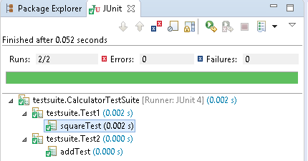

4.3 Ignore Test
@Ignore annotation is used to create Ignore test. We use @ignore in two cases
1. At Method Level : if a method annotated with @Ignore, that method will not be executed.
2. At Class Level Level : if a class annotated with @Ignore, all its methods will not be executed.
1. Class to be tested
package ignoretest;
public class IgnoreTestClassLevel {
private String str1;
private String str2;
private String str3;

public IgnoreTestClassLevel(String str1, String str2) {
this.str1 = str1;
this.str2 = str2;
}

public String addStrings() {
str3 = str1 + str2;
System.out.println("addStrings : " + str3);
return str1 + str2;
}

public String upperCase() {
str3 = (str1 + str2).toUpperCase();
System.out.println("upperCase : " + str3);
return str1 + str2;
}
}

2. Ignore Test at Method Level
package ignoretest;
import org.junit.Test;
import org.junit.Ignore;
import static org.junit.Assert.assertEquals;

public class IgnoreTestMethodLevel {
StringUtil util = new StringUtil("a", "b");
String res = "";

@Ignore
@Test
public void testAddStrings() {
System.out.println("Inside testAddStrings()");
res = "ab";
assertEquals(res, util.addStrings());
}

@Test
public void testUpperCase() {
System.out.println("Inside testUpperCase()");
res = "AB";
assertEquals(res, util.upperCase());
}
}
Inside testUpperCase()
upperCase : AB
Success : true

3. Ignore Test at Class Level
package ignoretest;
import org.junit.Test;
import org.junit.Ignore;
import static org.junit.Assert.assertEquals;

@Ignore
public class IgnoreTestClassLevel {
StringUtil util = new StringUtil("a", "b");
String res = "";

@Test
public void testAddStrings() {
System.out.println("Inside testAddStrings()");
res = "ab";
assertEquals(res, util.addStrings());
}

@Test
public void testUpperCase() {
System.out.println("Inside testUpperCase()");
res = "AB";
assertEquals(res, util.upperCase());
}
}
Empty Output, because none of its test methods will be executed.

4.4 Time Test
@Test(timeout)- timeout parameter along with @Test annotation as used for Time Test.If a test case takes more time than the specified number of milliseconds, then JUnit will automatically mark it as failed.
Example: Time Test example for above StringUtil.java Class
package ignoretest;
import org.junit.Test;
import org.junit.Ignore;
import static org.junit.Assert.assertEquals;

public class StringUtilTimeTest {
StringUtil util = new StringUtil("a", "b");
String res = "";

@Test(timeout = 1000)
public void testAddStrings() {
System.out.println("Inside testAddStrings()");
res = "ab";
assertEquals(res, util.addStrings());
}

@Test
public void testUpperCase() {
System.out.println("Inside testUpperCase()");
res = "AB";
assertEquals(res, util.upperCase());
}
}

4.5 Exceptions Test
@Test(expected)- expected parameter along with @Test annotation as used for Exceptions Test. we can test whether our code throws an expected exception or not
Example: ExceptionsTest
package junit;

public class Calculator {
public int square(int x) {
return x * x;
}
public int div(int a, int b) {
return a / b;
}
}

package junit;
import static org.junit.Assert.*;
import org.junit.Test;

public class CaluculatorExceptionTest {
@Test(expected = ArithmeticException.class)
public void divTest() {
Calculator calculator = new Calculator();
int res = calculator.div(12,0); //success
// int res = calculator.div(12,0); //error
assertEquals(4, res);
}
}

4.6 Parameterized Test
Parameterized tests allow a developer to run the same test over and over again using different values.we use @RunWith(Parameterized.class) to achive this type of tests.
Example
public class EvenNumbers {
public Boolean checkEven(final Integer num) {

for (int i = 1; i <= num; i++) {
if (i % 2 == 0) {
return true;
}
}
return false;
}
}

package parameterizedtest;

import java.util.*;
import org.junit.*;
import static org.junit.Assert.assertEquals;

@RunWith(Parameterized.class)
public class PrimeNumberCheckerTest {
private Integer inum;
private Boolean res;
private EvenNumbers evenObj;

@Before
public void initialize() {
evenObj = new EvenNumbers();
}

public PrimeNumberCheckerTest(Integer inum, Boolean res) {
this.inum = inum;
this.res = res;
}

@Parameterized.Parameters
public static Collection evenNumbers() {
return Arrays.asList(new Object[][] {
{ 2, true },
{ 6, true },
{ 18, true },
{ 19, false },
{ 48, true }
});
}

@Test
public void testPrimeNumberChecker() {
System.out.println("Parameterized Number is : " + inum);
assertEquals(res, evenObj.checkEven(inum));
}
}
Parameterized Number is : 2
Parameterized Number is : 6
Parameterized Number is : 18
Parameterized Number is : 19
Parameterized Number is : 48

4.7 JUnit List Example
package other;

import org.junit.Test;

import java.util.ArrayList;
import java.util.Arrays;
import java.util.List;
import org.hamcrest.collection.IsEmptyCollection;
import static org.hamcrest.CoreMatchers.*;
import static org.hamcrest.collection.IsCollectionWithSize.hasSize;
import static org.hamcrest.collection.IsIterableContainingInAnyOrder.containsInAnyOrder;
import static org.hamcrest.collection.IsIterableContainingInOrder.contains;
import static org.hamcrest.number.OrderingComparison.greaterThanOrEqualTo;
import static org.hamcrest.number.OrderingComparison.lessThan;
import static org.hamcrest.MatcherAssert.assertThat;

public class ListExample{

@Test
public void testAssertList() {

List<Integer> actual = Arrays.asList(1, 2, 3, 4, 5);
List<Integer> expected = Arrays.asList(1, 2, 3, 4, 5);

//All passed / true

//1. Test equal.
assertThat(actual, is(expected));

//2. Check List has this value
assertThat(actual, hasItems(2));

//3. Check List Size
assertThat(actual, hasSize(4));

assertThat(actual.size(), is(5));

//4. List order

// Ensure Correct order
assertThat(actual, contains(1, 2, 3, 4, 5));

// Can be any order
assertThat(actual, containsInAnyOrder(5, 4, 3, 2, 1));

//5. check empty list
assertThat(actual, not(IsEmptyCollection.empty()));

assertThat(new ArrayList<>(), IsEmptyCollection.empty());

//6. Test numeric comparisons
assertThat(actual, everyItem(greaterThanOrEqualTo(1)));

assertThat(actual, everyItem(lessThan(10)));

}

}

4.8 JUnit Map Example
public class MapExample {
@Test
public void testAssertMap() {

Map<String, String> map = new HashMap<>();
map.put("j", "java");
map.put("c", "c++");
map.put("p", "python");
map.put("n", "node");

Map<String, String> expected = new HashMap<>();
expected.put("n", "node");
expected.put("c", "c++");
expected.put("j", "java");
expected.put("p", "python");

//All passed / true

//1. Test equal, ignore order
assertThat(map, is(expected));

//2. Test size
assertThat(map.size(), is(4));

//3. Test map entry, best!
assertThat(map, IsMapContaining.hasEntry("n", "node"));

assertThat(map, not(IsMapContaining.hasEntry("r", "ruby")));

//4. Test map key
assertThat(map, IsMapContaining.hasKey("j"));

//5. Test map value
assertThat(map, IsMapContaining.hasValue("node"));

}
}

4.9 JUnit Tools
Following are the JUnit Tools used for Testing −
- Cactus
- JWebUnit
- XMLUnit
- MockObject

References
http://junit.org/junit4/
https://www.tutorialspoint.com/junit/
http://www.javatpoint.com/junit-tutorial
http://www.mkyong.com/tutorials/junit-tutorials/

Mockito
Mockito facilitates creating mock objects(sample , similar Objects). Mock objects are nothing but proxy for actual implementations.

1.Creating Mock Objects

1.Normal way
StockService stockServiceMock = mock(StockService.class);

2.Using Annotation
@Mock
StockService stockServiceMock

2.Methods & Usage
All trhese methods are static, import provided by Mockito
import static org.mockito.Mockito.*;

when(...).thenReturn(...); - adds a functionality to a mock object using the methods when(). Then()
when(...).thenReturn(...);

// mock the behavior of stock service to return the value of various stocks
when(stockServiceMock.getPrice(googleStock)).thenReturn(50.00);
when(stockServiceMock.getPrice(microsoftStock)).thenReturn(1000.00);

// @RunWith attaches a runner with the test class to initialize the test data
@RunWith(MockitoJUnitRunner.class)
public class MathApplicationTester {

//@InjectMocks annotation is used to create and inject the mock object
@InjectMocks //main Object
MathApplication mathApplication = new MathApplication();

//@Mock annotation is used to create the dependent mock object
@Mock //Calculator object id decalted inside MathApplication
CalculatorService calcService;

@Test
public void testAdd(){
//add the behavior of calc service to add two numbers
when(calcService.add(10.0,20.0)).thenReturn(30.00);

//test the add functionality
Assert.assertEquals(mathApplication.add(10.0, 20.0),30.0,0);
}
}

verify() method is ensure whether a mock method is being called with reequired arguments or not
//verify call to calcService is made or not with same arguments verify(calcService).add(20.0, 30.0);

Times() method - Suppose MathApplication should call the CalculatorService.serviceUsed() method only once
//check if add function is called three times
verify(calcService, times(3)).add(10.0, 20.0);

//verify that method was never called on a mock
verify(calcService, never()).multiply(10.0,20.0)

Mockito provides the following additional methods to vary the expected call counts
//check a minimum 1 call count
verify(calcService, atLeastOnce()).subtract(20.0, 10.0);

//check if add function is called minimum 2 times
verify(calcService, atLeast(2)).add(10.0, 20.0);

//check if add function is called maximum 3 times
verify(calcService, atMost(3)).add(10.0,20.0);

Exception
@Test(expected = RuntimeException.class)
public void testAdd(){
//add the behavior to throw exception
doThrow(new RuntimeException("Add operation not implemented"))
.when(calcService).add(10.0,20.0);
}

InOrder class - takes care of the order of method calls
//create an inOrder verifier for a single mock
InOrder inOrder = inOrder(calcService);

//following will make sure that add is first called then subtract is called.
inOrder.verify(calcService).subtract(20.0,10.0);
inOrder.verify(calcService).add(20.0,10.0);

reset - reset a mock so that it can be reused later
//reset the mock
reset(calcService);

spy()/@Spy: partial mocking, real methods are invoked but still can be verified and stubbed

Hamcrest Matchers
Hamcrest provides a more readable, declarative approach to asserting and matching your test results.
Hamcrest has the target to make tests as readable as possible. For example, the is method is a thin wrapper for equalTo(value).
import static org.hamcrest.MatcherAssert.assertThat;
import static org.hamcrest.Matchers.is;
import static org.hamcrest.Matchers.equalTo;

boolean a;
boolean b;

// all statements test the same
assertThat(a, equalTo(b));
assertThat(a, is(equalTo(b)));
assertThat(a, is(b));

The following snippets compare pure JUnit 4 assert statements with Hamcrest matchers.
// JUnit 4 for equals check
assertEquals(expected, actual);
// Hamcrest for equals check
assertThat(actual, is(equalTo(expected)));

// JUnit 4 for not equals check
assertNotEquals(expected, actual)
// Hamcrest for not equals check
assertThat(actual, is(not(equalTo(expected))));

The following are the most important Hamcrest matchers:
- allOf - matches if all matchers match (short circuits)
- anyOf - matches if any matchers match (short circuits)
- not - matches if the wrapped matcher doesn’t match and vice
- equalTo - test object equality using the equals method
- is - decorator for equalTo to improve readability
- hasToString - test Object.toString
- instanceOf, isCompatibleType - test type
- notNullValue, nullValue - test for null
- sameInstance - test object identity
- hasEntry, hasKey, hasValue - test a map contains an entry, key or value
- hasItem, hasItems - test a collection contains elements
- hasItemInArray - test an array contains an element
- closeTo - test floating point values are close to a given value
- greaterThan, greaterThanOrEqualTo, lessThan, lessThanOrEqualTo
- equalToIgnoringCase - test string equality ignoring case
- equalToIgnoringWhiteSpace - test string equality ignoring differences in runs of whitespace
- containsString, endsWith, startsWith - test string matching

Integration Testing
Integration testing is all about testing all pieces of an application working together as they would in a live or production environment

To convert any JUnit test into a proper integration test, there are really two basic things that you need to do.
- The first is you need to annotate your tests with the @RunWith annotation and specify that you want to run it with the SpringJUnit4ClassRunner.class

- The second is you need to add the @SpringApplicationConfiguration annotation and provide your main Spring Boot class for your application.
@RunWith(SpringJUnit4ClassRunner.class)
@SpringApplicationConfiguration(Demo.class)
public class UserRepoIntegrationTest {
@Autowired
private UserRepository userRepository;

@Test
public void testFindAll() {
List<User> users = userRepository.findAll();
assertThat(users.size(), is(greaterThanOrEqualTo(0)));
}
}

Regardless of the test result - successful or unsuccessful, open your IDE Console tab and you should notice that it looks like your application started (Spring logo, info etc). This happens because our application actually starts with integration tests

MockMvc
Spring MockMVC to perform integration testing of spring webmvc controllers

MockMVC class is part of Spring MVC test framework which helps in testing the controllers explicitly starting a Servlet container.
@RunWith(SpringRunner.class)
@WebMvcTest(StudentController.class)
public class StudentIntegrationTests {

@Autowired
private MockMvc mvc;
}

- SpringRunner is an alias for the SpringJUnit4ClassRunner.
- @WebMvcTest annotation is used for Spring MVC tests. It disables full auto-configuration and instead apply only configuration relevant to MVC tests.
- StudentController.class means initialize only this controller and provide dependent Mock object of this controller.

MockMvcRequestBuilders -hit the APIs & passing the path parameters and verify the status response codes
MockMvcResultMatchers – get the response content & matches with expected content

Types of Authentication
A servlet-based web application can choose from the following types of authentication, from least secure to most:
- Basic authentication
- Form-based authentication
- Digest authentication
- SSL and client certificate authentication

“Authentication” and “Authorization”. Authentication can be defined as the process of verifying someone’s identity by using pre-required details (Commonly username and password). Authorization is the process of allowing an authenticated user to access a specified resource (eg:-right to access a file).

HTTP Basic Authentication
- One solution is that of HTTP Basic Authentication. In this approach, an HTTP user agent simply provides a usernameand password to prove their authentication.

- This approach does not require cookies, session IDs, login pages, and other such specialty solutions, and because it uses the HTTP header itself, there’s no need to handshakes or other complex response systems.

- HTTP is not encrypted in any way. It is encapsulated in base64, and is often erroneously proclaimed as encrypted due to this

Digest authentication
The difference between digest authentication and basic authentication is that in digest authentication, the username and password are never sent over the wire. Instead, a hash is created made up of the following pieces of information:
- The username
- The password
- The URL
- The randomly generated string (the nonce)
- The HTTP method being used

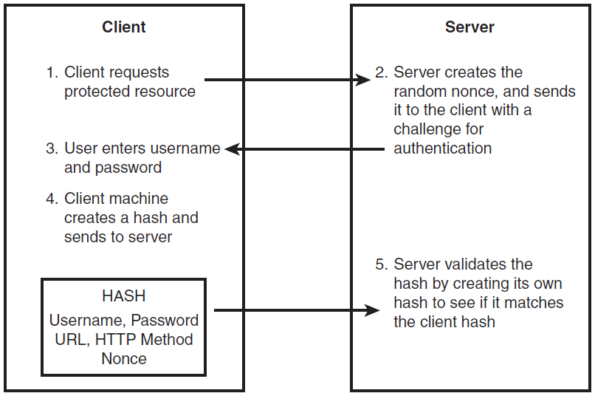

API Keys : for Developer Quickstart
- To access Bitbucket in Hygieia, we will generate API key, and we will place that key in properties file.

- API Keys can be used as Basic HTTP Authentication credentials and provide a substitute for the account's actual username and password.

- The best thing about an API key is its simplicity. You merely log in to a service, find your API key (often in the settings screen), and copy it to use in an application, test in the browser, or use with one of these API request tools

- Typically, an API key gives full access to every operation an API can perform, including writing new data or deleting existing data. If you use the same API key in multiple apps, a broken app could destroy your users' data without an easy way to stop just that one app.

- Many API keys are sent in the query string as part of the URL, which makes it easier to discover for someone who should not have access to it. A better option is to put the API key in the Authorization header. In fact, that’s the proposed standard:
Authorization: Apikey 1234567890abcdef

OAuth Tokens: Great for Accessing User Data
- OAuth is the answer to accessing user data with APIs.

- users simply click a button to allow an application to access their accounts.
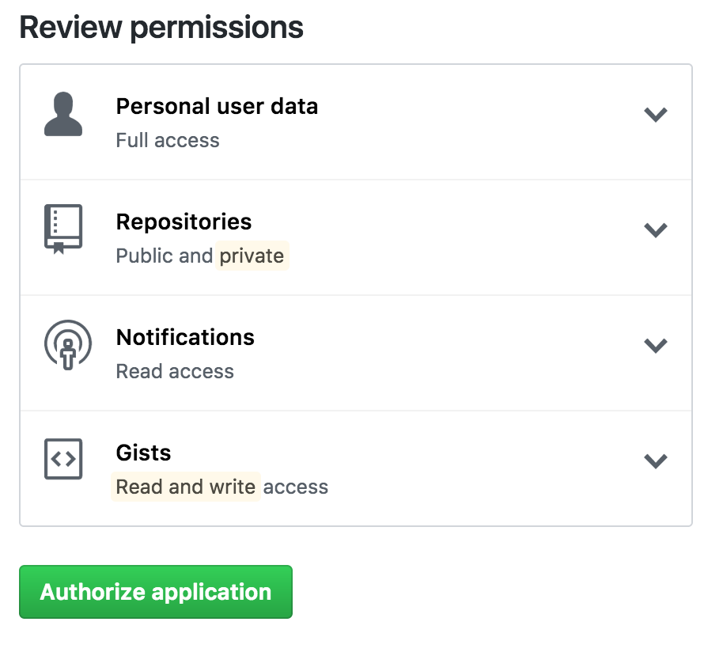

LDAP
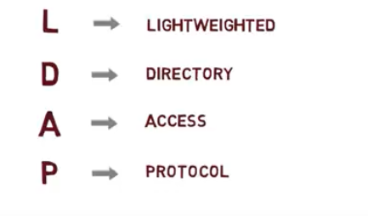
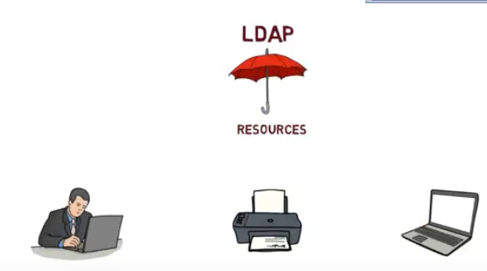
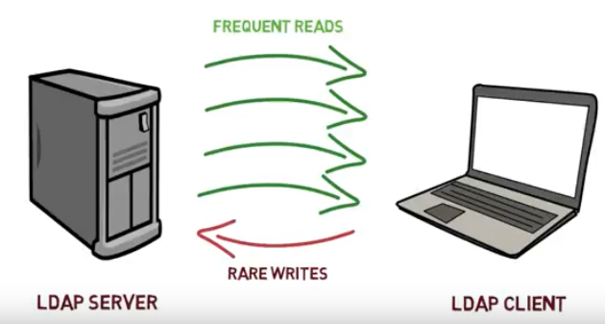
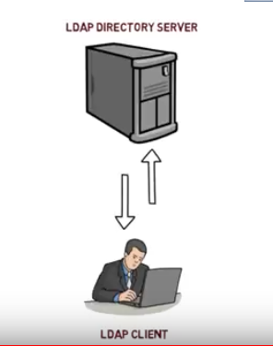
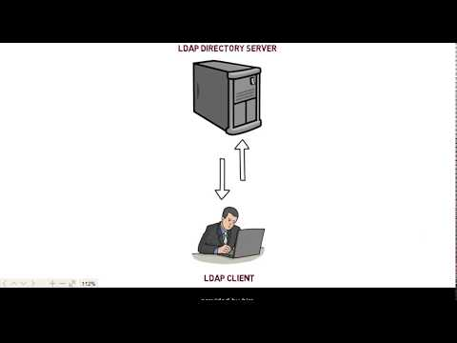
https://www.youtube.com/watch?v=lp5z8HQGAH8

import javax.naming.*;
import javax.naming.directory.*;
import java.util.Hashtable;

class Simple {
public static void main(String[] args) {
Hashtable authEnv = new Hashtable(11);
String userName = "johnlennon";
String passWord = "sushi974";
String base = "ou=People,dc=example,dc=com";
String dn = "uid=" + userName + "," + base;
String ldapURL = "ldap://ldap.example.com:389";

authEnv.put(Context.INITIAL_CONTEXT_FACTORY,"com.sun.jndi.ldap.LdapCtxFactory");
authEnv.put(Context.PROVIDER_URL, ldapURL);
authEnv.put(Context.SECURITY_AUTHENTICATION, "simple");
authEnv.put(Context.SECURITY_PRINCIPAL, dn);
authEnv.put(Context.SECURITY_CREDENTIALS, passWord);

try {
DirContext authContext = new InitialDirContext(authEnv);
System.out.println("Authentication Success!");
} catch (AuthenticationException authEx) {
System.out.println("Authentication failed!");
} catch (NamingException namEx) {
System.out.println("Something went wrong!");
namEx.printStackTrace();
}
}
}

SSH – Only for LINUX Server / CommadLine(git) related Access
- SSH, or secure shell, is an encrypted protocol used to administer and communicate with servers. When working with a Linux server, chances are, you will spend most of your time in a terminal session connected to your server through SSH.

- An SSH server can authenticate clients using a variety of different methods. The most basic of these is password authentication, which is easy to use, but not the most secure.

- SSH key pairs are two cryptographically secure keys that can be used to authenticate a client to an SSH server. Each key pair consists of a public key and a private key.

- The private key is retained by the client and should be kept absolutely secret. Any compromise of the private key will allow the attacker to log into servers that are configured with the associated public key without additional authentication. As an additional precaution, the key can be encrypted on disk with a passphrase.

- The associated public key can be shared freely without any negative consequences. The public key can be used to encrypt messages that only the private key can decrypt. This property is employed as a way of authenticating using the key pair.

- The public key is uploaded to a remote server that you want to be able to log into with SSH. The key is added to a special file within the user account you will be logging into called ~/.ssh/authorized_keys.

- When a client attempts to authenticate using SSH keys, the server can test the client on whether they are in possession of the private key. If the client can prove that it owns the private key, a shell session is spawned or the requested command is executed.
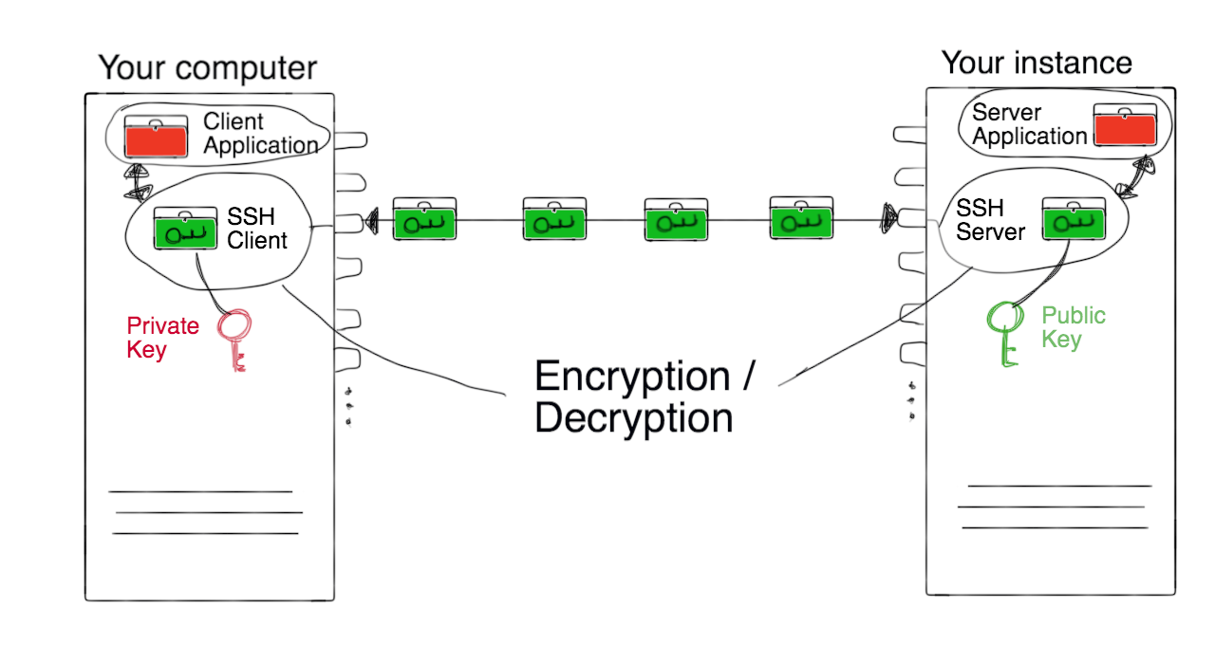

Base64 – not Authentication
represent binary data in an ASCII string format
Each Base64 digit represents exactly 6 bits of data.
Steps:
- take three ASCII numbers 155, 162, and 233
- Convert into binary stream formate 100110111010001011101001
- groupings of six characters: 100110 111010 001011 101001.
- The binary string 100110 converts to the decimal number 38: 0*2^01 + 1*2^1 + 1*2^2 + 0*2^3 + 0*2^4 + 1*2^5 = 0+2+4+0+0+32.
- Base64 6-bit values 38, 58, 11 and 41.
- Using the Base64 conversion table:
  - 38 is m
  - 58 is 6
  - 11 is L
  - 41 is p

Help.html

StudentApp Document

StudentApp + AngularJs+ CurdRepository+MockMVC References
CURD + POSTMAN
https://www.callicoder.com/spring-boot-rest-api-tutorial-with-mysql-jpa-hibernate/
AngularJS+Templates
https://examples.javacodegeeks.com/enterprise-java/spring/boot/spring-boot-and-angularjs-integration-tutorial/
Spring+AngularJS Controllers
https://java2blog.com/spring-boot-angularjs-example/

SpringBoot MockMVC Tutorial
- Mokito : https://howtodoinjava.com/spring-boot2/spring-boot-mockito-junit-example/
- MOCK MVC : https://howtodoinjava.com/spring-boot2/spring-boot-mockmvc-example/

StudentApp MongoRepository
Example App : https://www.journaldev.com/18156/spring-boot-mongodb

1. Add Maven Dependency: spring-boot-starter-data-mongodb
2.Create Sudent Collection
>use student
>db.createCollection("student");
>db.student.insert(
{
sno: 501,
name: "Satya Kaveti",
city:"Vijayawada",
marks:508
}
)

3.in application.propertis , add Mongo DB details
spring.data.mongodb.database=student
spring.data.mongodb.port=27017
spring.data.mongodb.host=localhost

2.Create StudentModel.java with @Document & Id annotations
3.create StudentMongoRepository extends MongoRepository
4.Create StudentMongoController.java

How can Spring Boot work without driver configuration?
Spring Boot gives you defaults on all things, the default in database is H2, so when you want to change this and use any other database you must define the connection attributes in the application.properties file.
- H2 is one of the popular in memory databases. Spring Boot has default integration for H2
- is live only during the time of execution of the application, not for real world applications
- The h2-*.jar is just an engine (the code) of the database. It is read-only and it does not store any information. The data in H2 can be stored either in memory or on disk in a specified file. You are actually specifying one:

In our Application we are using MySQL, so we provided details with out Driver detilas
spring.datasource.url = jdbc:mysql://localhost:3306/student?useSSL=false
spring.datasource.username = root
spring.datasource.password = root

<dependency>
<groupId>org.springframework.boot</groupId>
<artifactId>spring-boot-starter-data-jpa</artifactId>
</dependency>

<dependency>
<groupId>mysql</groupId>
<artifactId>mysql-connector-java</artifactId>
<scope>runtime</scope>
</dependency>

- @EnableAutoConfiguration : This annotation tells Spring to automatically configure your application based on the dependencies that you have added in the pom.xml file.

- For example, If spring-data-jpa or spring-jdbc is in the classpath, then it automatically tries to configure a DataSource by reading the database properties from application.properties file.

- So,in above we just have to add the configuration and Spring Boot will take care of the rest.

- In the above properties file, the last two properties are for hibernate. Spring Boot uses Hibernate as the default JPA implementation.

- If you remove mysql-connector-java from pom.xml, SpringBoot unable to find the MySQL related java classes in insert application.propeties values to create datasource, it will throw below error.
Failed to bind properties under '' to com.zaxxer.hikari.HikariDataSource:
Property: driverclassname
Value: com.mysql.cj.jdbc.Driver
Origin: "driverClassName" from property source "source"
Reason: Failed to load driver class com.mysql.cj.jdbc.Driver in either of HikariConfig class loader or Thread context classloader

Action:
Update your application's configuration
So finally, SpringBoot uses Drivers & all normal stuff though @EnableAutoConfiguration to do the job

Spring Boot with multiple databases
In Our StudentApp we have multiple Databases.
1.if we use only one Database :MySQL we can use default spring.data.*properties. Spring @EnableAutoConfiguration will create Datasource by reading these properties
spring.datasource.url = jdbc:mysql://localhost:3306/student?useSSL=false
spring.datasource.username = root
spring.datasource.password = root

2.if we use two databases :MySQL, Mongo we can use default spring.data.*properties of therir respective databases. Spring @EnableAutoConfiguration will create two different Datasource by reading these properties
spring.data.mongodb.database=student
spring.data.mongodb.port=27017
spring.data.mongodb.host=localhost

3.If we use two DB’s with our own Config properties we need to Ovveride DataSource Manually
#----------- MySQL -------------
own.spring.mysql.datasource.url = jdbc:mysql://localhost:3306/student?useSSL=false
own.spring.mysql.datasource.username = root
own.spring.mysql.datasource.password = root

#----------- MongoDB -------------
own.spring.mongo.datasource.database=student
own.spring.mongo.datasource.port=27017
own.spring.mongo.datasource.host=localhost

Because we want the Spring Boot autoconfiguration to pick up those different properties (and actually instantiate two different DataSources), we need to instantiate our DataSource beans manually in a configuration class
@Configuration
public class MultipleDataSourceConfiguration {
@Bean
@Primary
@ConfigurationProperties(prefix="own.spring.mysql.datasource")
public DataSource primaryDataSource() {
return DataSourceBuilder.create().build();
}
@Bean
@ConfigurationProperties(prefix="own.spring.mongo.datasource")
public DataSource secondaryDataSource() {
return DataSourceBuilder.create().build();
}
}
- https://medium.com/@joeclever/using-multiple-datasources-with-spring-boot-and-spring-data-6430b00c02e7
- http://www.java2novice.com/spring-boot/configure-multiple-datasources/
- https://www.infoq.com/articles/Multiple-Databases-with-Spring-Boot

@Conditional & @Profilers
While developing Spring based applications we may come across a need to register beans conditionally.
For example, you may want to register a DataSource bean pointing to the dev database abd different production database while running in production.
To address this problem, Spring 3.1 introduced the concept of Profiles. When you run the application you can activate the desired profiles ,and only those beans of that profiles will be registered.
@Configuration
public class AppConfig
{
@Bean
@Profile("DEV")
public DataSource devDataSource() {
...
}
@Bean
@Profile("PROD")
public DataSource prodDataSource() {
...
}
}
Then you can specify the active profile using System Property -Dspring.profiles.active=DEV

Now we can configure both JdbcUserDAO and MongoUserDAO beans conditionally using @Conditionalas follows:
@Configuration
public class AppConfig
{
@Bean
@Conditional(MySQLDatabaseTypeCondition.class)
public UserDAO jdbcUserDAO(){
return new JdbcUserDAO();
}
@Bean
@Conditional(MongoDBDatabaseTypeCondition.class)
public UserDAO mongoUserDAO(){
return new MongoUserDAO();
}
}

How EnableAutoConfiguration implemented?
auto-configuration is implemented with standard @Configuration classes. Additional @Conditional annotations are used to constrain when the auto-configuration should apply.

SpringBoot Security
spring-boot-starter-security: take care of all the required dependencies related to spring security.
<dependency>
<groupId>org.springframework.boot</groupId>
<artifactId>spring-boot-starter-security</artifactId>
</dependency>
This will include the SecurityAutoConfiguration class – containing the initial/default security configuration.
Just Run the project & see the magic
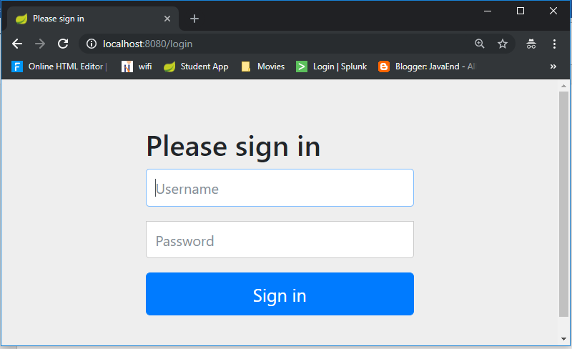
We never created this login form, but from where it came from?
SpringSecurity default comes with login page & you can login with generated password which is already printed in the console
Using generated security password: 8b4667a4-cc3a-47fd-b51f-b6f5e83745df
Def.user name is : user

You can change the password by providing a security.user.password. This and other useful properties are externalized via SecurityProperties (properties prefix "security").
security.user.name=user
security.user.name=password
security.basic.enabled=true

To discard the security auto-configuration and add our own configuration, we need to exclude the SecurityAutoConfiguration class.
@SpringBootApplication(exclude = { SecurityAutoConfiguration.class })
public class SpringBootSecurityApplication {
public static void main(String[] args) {
SpringApplication.run(SpringBootSecurityApplication.class, args);
}
}

Or by adding some configuration into the application.properties file:
spring.autoconfigure.exclude=org.springframework.boot.autoconfigure.security.SecurityAutoConfiguration

If we disabling security auto-configuration, we need to provide our own configuration, by extends WebSecurityConfigurerAdapter
@Configuration
@EnableWebSecurity
public class SecurityConfig extends WebSecurityConfigurerAdapter {

@Override
public void configure(HttpSecurity http) throws Exception {
// It allows configuring web based security for specific http requests
http
.authorizeRequests()
.anyRequest().authenticated()
.and()
.formLogin()
.and()
.httpBasic();

/* ============ Custom login Page URL ==========
http
.authorizeRequests()
.antMatchers("/admin/**").hasRole("ADMIN")
.antMatchers("/anonymous*").anonymous()
.antMatchers("/login*").permitAll()
.anyRequest().authenticated()
.and()
.formLogin()
.loginPage("/login.html")
.loginProcessingUrl("/perform_login")
.defaultSuccessUrl("/homepage.html", true)
//.failureUrl("/login.html?error=true")
.failureHandler(authenticationFailureHandler())
.and()
.logout()
.logoutUrl("/perform_logout")
.deleteCookies("JSESSIONID")
.logoutSuccessHandler(logoutSuccessHandler());
*/
}

@Bean
@Override
public UserDetailsService userDetailsService() {
UserDetails user =
User.withDefaultPasswordEncoder()
.username("user")
.password("user")
.roles("USER")
.build();

return new InMemoryUserDetailsManager(user);
}

}

Let’s summarize what we did in order to add Spring Boot Security to his web app. To secure his web app,
- we added Spring Boot Security to the classpath.
- Once it was in the classpath, Spring Boot Security was enabled by default.
- Then customized the security by extending WebSecurityConfigurerAdapter and added his own configure and userDetailsServiceimplementation.
- http://localhost:8080/login?logout
- https://docs.spring.io/spring-security/site/docs/current/guides/html5/form-javaconfig.html
- https://examples.javacodegeeks.com/enterprise-java/spring/boot/spring-boot-security-example/

SpringBoot AOP
Actually we don’t have Spring AOP starter in Springboot, but we can integrate using traditional Spring Framework
<dependency>
<groupId>org.springframework</groupId>
<artifactId>spring-aop</artifactId>
<version>5.0.1.RELEASE</version>
<scope>compile</scope>
</dependency>
<dependency>
<groupId>org.aspectj</groupId>
<artifactId>aspectjweaver</artifactId>
<version>1.8.12</version>
<scope>compile</scope>
</dependency>
Applications are generally developed with multiple layers. A typical Java application has
- Web Layer - Exposing the services to outside world using REST or a web application
- Business Layer - Business Logic
- Data Layer - Persistence Logic
While the responsibilities of each of these layers are different, there are a few common aspects that apply to all layers
- Logging
- Security

In this example we are implementing Logging – we are trying to Log the all the Application flow like, what controller is calling, what method is executing on performing certain operation.
package app.aop;

@Aspect
@Configuration
public class StudentAOP {

private Logger logger = LoggerFactory.getLogger(this.getClass());

//What kind of method calls I would intercept
//execution(* PACKAGE.*.*(..))
//Weaving & Weaver
@Before("execution(* app.repository.*.*(..))")
public void before(JoinPoint joinPoint){
//Advice
logger.info(" \n \n====== @Before===== \t app.repository");
logger.info(" Allowed execution for {}", joinPoint);
logger.info(" ====== @Before===== \n \n");
}

@AfterReturning(value = "execution(* app.controller.*.*(..))",
returning = "result")
public void afterReturning(JoinPoint joinPoint, Object result) {
logger.info("\n \n ====== @AfterReturning ===== \t : app.controller ");
logger.info("{} returned with value {}", joinPoint, result);
logger.info(" ====== @AfterReturning ===== \n \n");
}

@After(value = "execution(* app.security.*.*(..))")
public void after(JoinPoint joinPoint) {
logger.info("\n \n ====== @After ===== \t : app.security");
logger.info("after execution of {}", joinPoint);
logger.info(" ====== @After ===== \n \n");
}

}

====== @After ===== : app.security
2019-02-10 22:50:12.232 INFO 8152 --- [ main] dentAOP$$EnhancerBySpringCGLIB$$bb027782 : after execution of execution(UserDetailsService app.security.SecurityConfig.userDetailsService())
2019-02-10 22:50:12.236 INFO 8152 --- [ main] dentAOP$$EnhancerBySpringCGLIB$$bb027782 : ====== @After =====

====== @AfterReturning ===== : app.controller
2019-02-10 22:43:58.212 INFO 2440 --- [nio-8080-exec-7] dentAOP$$EnhancerBySpringCGLIB$$45dcbfee : execution(List app.controller.StudentMongoController.getAllStudents()) returned with value [Student [sno=501, name=vinay, city=karnool, marks=545], Student [sno=502, name=VINOD, city=BNHGG, marks=456]]
2019-02-10 22:43:58.212 INFO 2440 --- [nio-8080-exec-7] dentAOP$$EnhancerBySpringCGLIB$$45dcbfee : ====== @AfterReturning =====

Getting all users.2019-02-10 22:43:58.248 INFO 2440 --- [nio-8080-exec-9] dentAOP$$EnhancerBySpringCGLIB$$45dcbfee :

====== @AfterReturning ===== : app.controller
2019-02-10 22:43:58.248 INFO 2440 --- [nio-8080-exec-9] dentAOP$$EnhancerBySpringCGLIB$$45dcbfee : execution(List app.controller.StudentMongoController.getAllStudents()) returned with value [Student [sno=501, name=vinay, city=karnool, marks=545], Student [sno=502, name=VINOD, city=BNHGG, marks=456]]
2019-02-10 22:43:58.248 INFO 2440 --- [nio-8080-exec-9] dentAOP$$EnhancerBySpringCGLIB$$45dcbfee : ====== @AfterReturning =====

Pointcut - Pointcut is the expression used to define when a call to a method should be intercepted. In the above example, "execution(* app.repository.*.*(..))" is the pointcut.
Advice - It is the logic that you would want to exceute when you intercept a method. In the above example, it is the code inside the before(JoinPoint joinPoint)method.
Aspect – is the Class we defiend, combination of on which method (Pointcut) and what to do (Advice) is called an Aspect.
Join Point - When the code is executed and the condition for pointcut is met, the advice is executed. The Join Point is a specific execution instance of an advice.
Weaver - Weaver is the framework which implements AOP - AspectJ or Spring AOP.
- http://www.springboottutorial.com/spring-boot-and-aop-with-spring-boot-starter-aop
- https://www.javainuse.com/spring/spring-boot-aop

SpringBoot Acuator - Health check, Auditing, Metrics,Monitoring
Actuator brings production-ready features to our application.
Monitoring our app, gathering metrics, understanding traffic or the state of our database becomes trivial with this dependency.
<dependency>
<groupId>org.springframework.boot</groupId>
<artifactId>spring-boot-starter-actuator</artifactId>
</dependency>
Once above maven dependency is included in the POM file, 16 different actuator REST endpoints, such as actuator, beans, dump, info, loggers, and metrics are exposed

Some of important and widely used actuator endpoints are given below:
ENDPOINT | USAGE
/env | Returns list of properties in current environment
/health | Returns application health information.
/auditevents | Returns all auto-configuration candidates and the reason why they ‘were’ or ‘were not’ applied.
/beans | Returns a complete list of all the Spring beans in your application.
/trace | Returns trace logs (by default the last 100 HTTP requests).
/dump | It performs a thread dump.
/metrics | It shows metrics information like JVM memory used, system CPU usage, open files, and much more.

You can access all avaible endpoint by this URL: http://localhost:8080/actuator
{
"_links": {
"self": {
"href": "http://localhost:8080/actuator",
"templated": false
},
"health": {
"href": "http://localhost:8080/actuator/health",
"templated": false
},
"health-component-instance": {
"href": "http://localhost:8080/actuator/health/{component}/{instance}",
"templated": true
},
"health-component": {
"href": "http://localhost:8080/actuator/health/{component}",
"templated": true
},
"info": {
"href": "http://localhost:8080/actuator/info",
"templated": false
}
}
}
If you see we have only 2 endpoints showing (health, info) out of 16 endpoints
By default, all the actuator endpoints are exposed over JMX but only the health and info endpoints are exposed over HTTP.

Here is how you can expose actuator endpoints over HTTP and JMX using application properties -
Exposing Actuator endpoints over HTTP
# Use "*" to expose all endpoints, or a comma-separated list to expose selected ones
management.endpoints.web.exposure.include=*
management.endpoints.web.exposure.exclude=

Exposing Actuator endpoints over JMX
# Use "*" to expose all endpoints, or a comma-separated list to expose selected ones
management.endpoints.jmx.exposure.include=*
management.endpoints.jmx.exposure.exclude=

Securing Actuator Endpoints with Spring Security
Actuator endpoints are sensitive and must be secured from unauthorized access. you can add spring security to your application using the following dependency -
<dependency>
<groupId>org.springframework.boot</groupId>
<artifactId>spring-boot-starter-security</artifactId>
</dependency>

we can override the default spring security configuration and define our own access rules.

Creating a Custom Actuator Endpoint
To customize the endpoint and define your own endpoint, simply Create a classs annotate with @Endpoint URL :
import org.springframework.boot.actuate.endpoint.annotation.Endpoint;
import org.springframework.boot.actuate.endpoint.annotation.ReadOperation;
import org.springframework.stereotype.Component;

@Endpoint(id="helloEndpoint")
@Component
public class ListEndPoints {
@ReadOperation
public String mypoint(){
return "Hello" ;
}
}
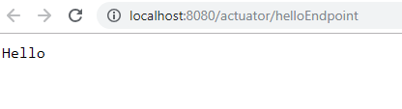
Few more Endpoints
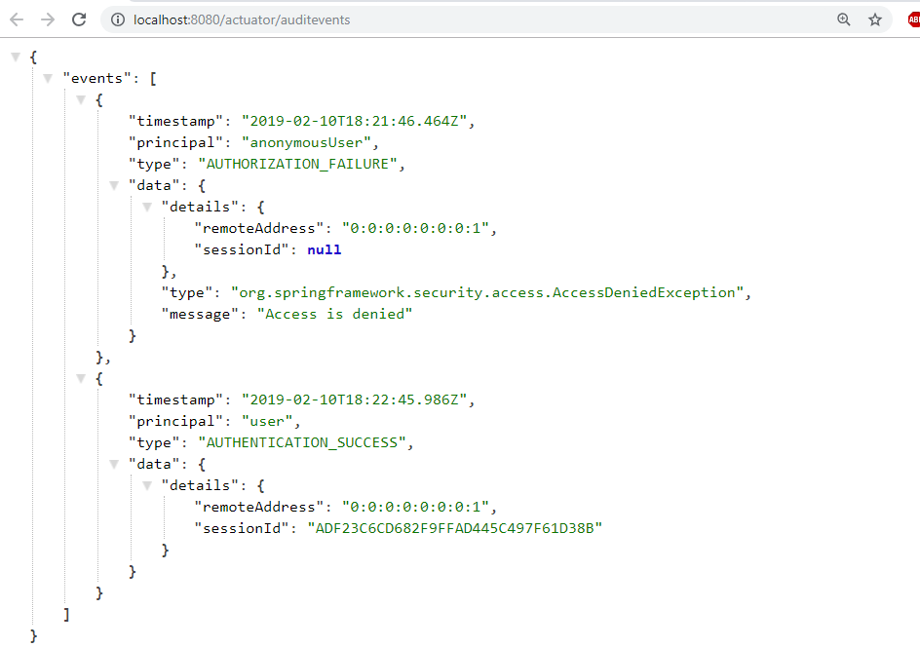
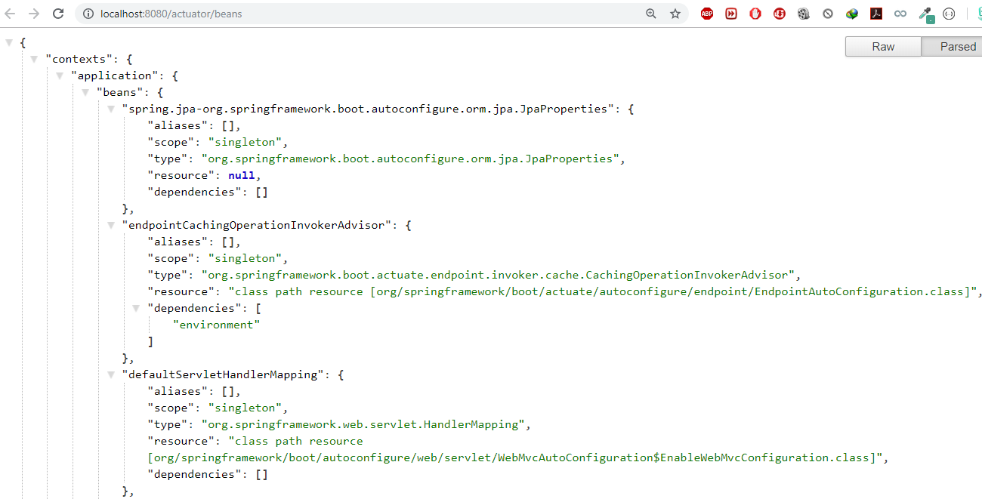
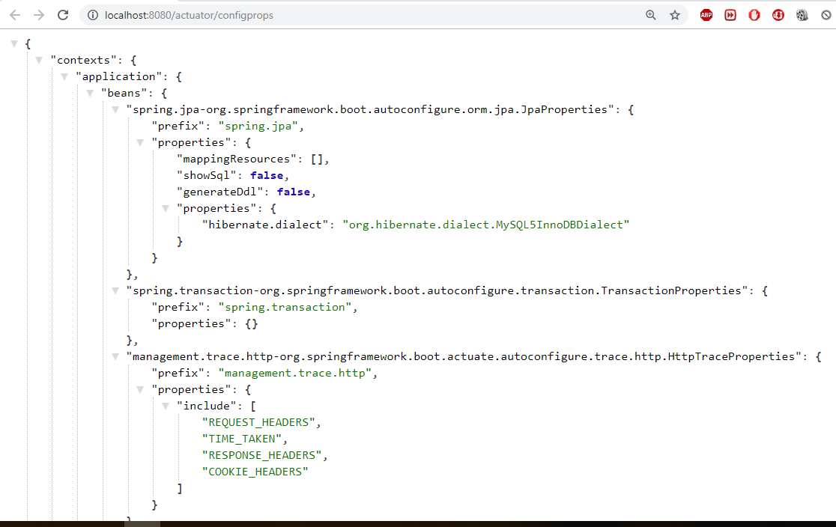
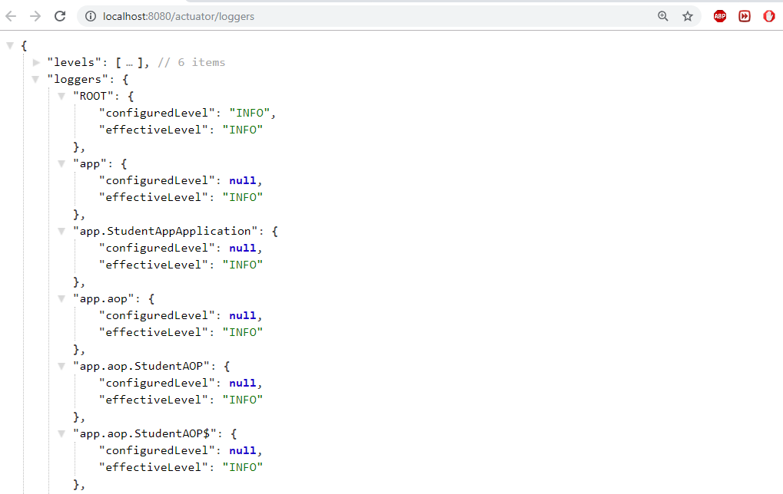
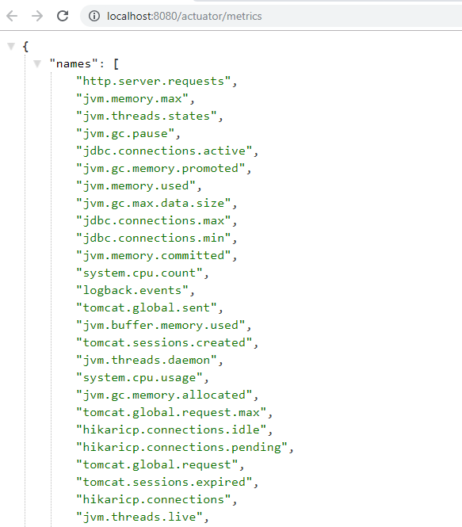

https://dzone.com/articles/spring-boot-actuator-a-complete-guide
https://www.callicoder.com/spring-boot-actuator/

Spring cloud
Spring Cloud focuses on providing good out of box experience for typical use cases and extensibility mechanism to cover others.
- Distributed/versioned configuration
- Service registration and discovery
- Routing
- Service-to-service calls
- Load balancing
- Circuit Breakers
- Global locks
- Leadership election and cluster state
- Distributed messaging
https://github.com/Debesh1234/DemoSpringBootProjects
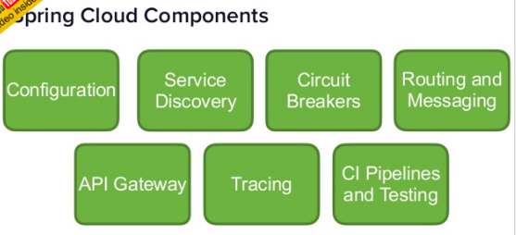
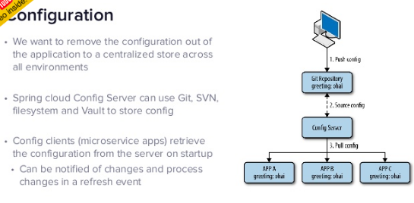
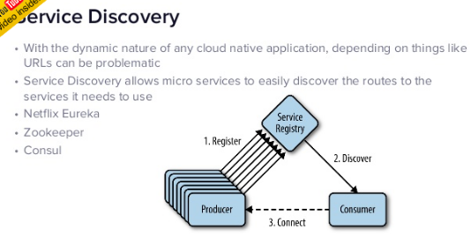
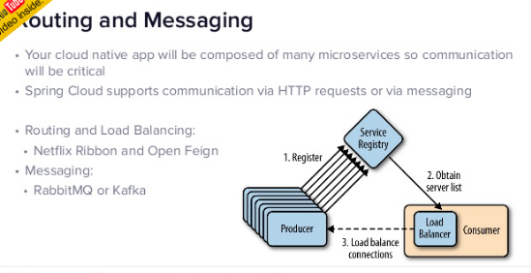
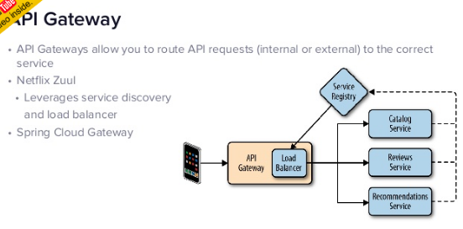

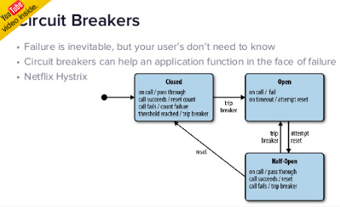
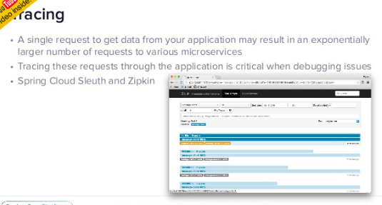
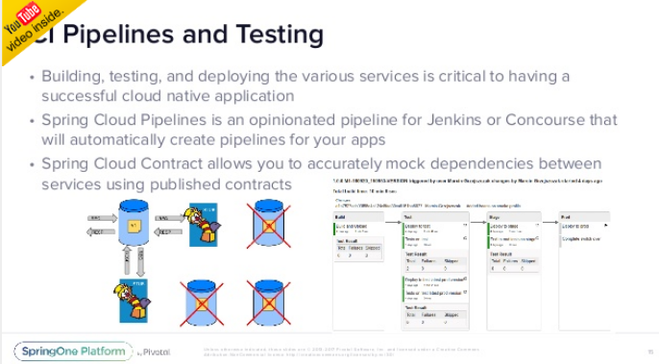
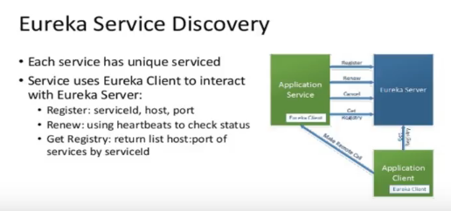
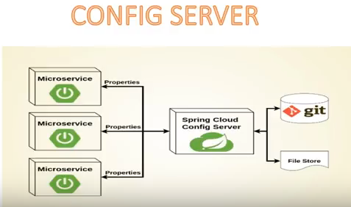
Read it Enough : http://www.optisolbusiness.com/Micro-Services-Architecture-Spring-Boot-and-Netflix-Infrastructure.pdf

SpringBoot MicroServices
Microservices allows us to break our large system into the number of independent collaborating processes.
Shopping system without Microservices (Monolith architecture)
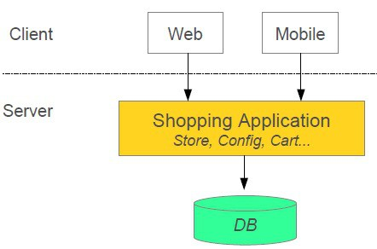
Shopping system with Microservices
In this architecture style, the main application divided into a set of sub-applications called microservices. One large Application divided into multiple collaborating processes as below.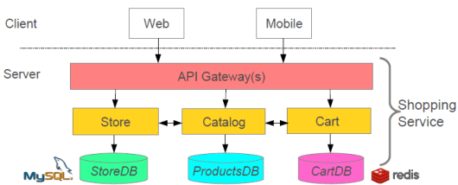

Microservices Benefits
- The smaller code base is easy to maintain.
- Easy to scale as an individual component.
- Technology diversity i.e. we can mix libraries, databases, frameworks etc.
- Fault isolation i.e. a process failure should not bring the whole system down.
- Better support for smaller and parallel team.
- Independent deployment
- Deployment time reduce

Microservices Challenges
- Distributed System so hard to debug and trace the issues
- Greater need for an end to end testing
- Required cultural changes in across teams like Dev and Ops working together even in the same team.

Microservices Tooling Supports
1. Use Spring for creating Microservices
- Setup new service by using Spring Boot
- Expose resources via a RestController
- Consume remote services using RestTemplat
2.Service Discovery
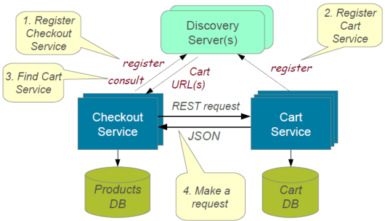
To build a simple microservices system following steps required
- Creating Discovery Service (Creating Eureka Discovery Service)
- Creating MicroService (the Producer), Register itself with Discovery Service with logical service.
3. Create Microservice Consumers find Service registered with Discovery ServiceDiscovery client using a smart RestTemplate to find microservice.

Example:
In this Example we have 3 Micro services should communicate each other.
Each micrpservice could have seprate Server & Separate DB
Discovery Server

Register Service
User
Server
Accounts
Server

1. Discovery Microservice server – To register microservice URLS
https://github.com/dineshonjava/discovery-microservice-server
@EnableEurekaServer –EurekaServer Acts as a Discovery Server. To Make our class as Discovery server use @EnableEurekaServer on the top of Spring Application class
@SpringBootApplication
@EnableEurekaServer
public class DiscoveryMicroserviceServerApplication {

public static void main(String[] args) {
SpringApplication.run(DiscoveryMicroserviceServerApplication.class, args);
}
}

Run this Eureka Server application with right click and run as Spring Boot Application and open in browser http://localhost:1111/
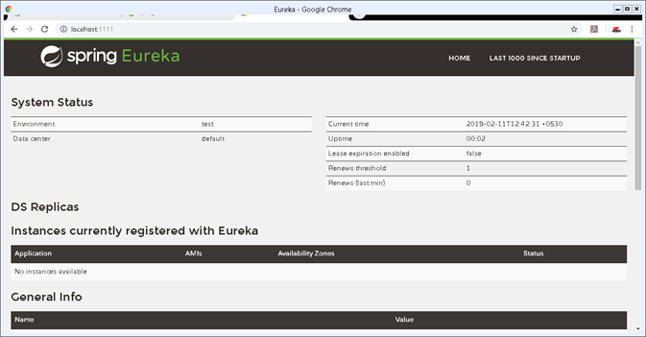

2. Accounts Microservice Server – It conatins Bank Account Deatils
https://github.com/dineshonjava/accounts-microservice-server
Account.java – for Account details
public class Account implements Serializable{

private static final long serialVersionUID = 1L;
private Long amount;
private String number;
private String name;
//Setter and getters
}
AccountController – all these Controller urs are Registers with Discovery Service
@RestController
public class AccountController {

protected Logger logger = Logger
.getLogger(AccountController.class.getName());

@Autowired
AccountRepository accountRepository;

@RequestMapping("/accounts")
public Account[] all() {
logger.info("accounts-microservice all() invoked");
List<Account> accounts = accountRepository.getAllAccounts();
logger.info("accounts-microservice all() found: " + accounts.size());
return accounts.toArray(new Account[accounts.size()]);
}

@RequestMapping("/accounts/{id}")
public Account byId(@PathVariable("id") String id) {
logger.info("accounts-microservice byId() invoked: " + id);
Account account = accountRepository.getAccount(id);
logger.info("accounts-microservice byId() found: " + account);
return account;
}
}

To make all our controller URLS register with Discovery server, we need to annotate our main Spring Application class with @EnableDiscoveryClient
@SpringBootApplication
@EnableDiscoveryClient
public class AccountsMicroserviceServerApplication {

public static void main(String[] args) {
SpringApplication.run(AccountsMicroserviceServerApplication.class, args);
}

}
Now run this account service application as Spring Boot application and after few seconds refresh the browser to the home page of Eureka Discovery Server at http://localhost:1111/ .
Now one Service registered to the Eureka registered instances with Service Name “ACCOUNT-MICROSERVICE” as below
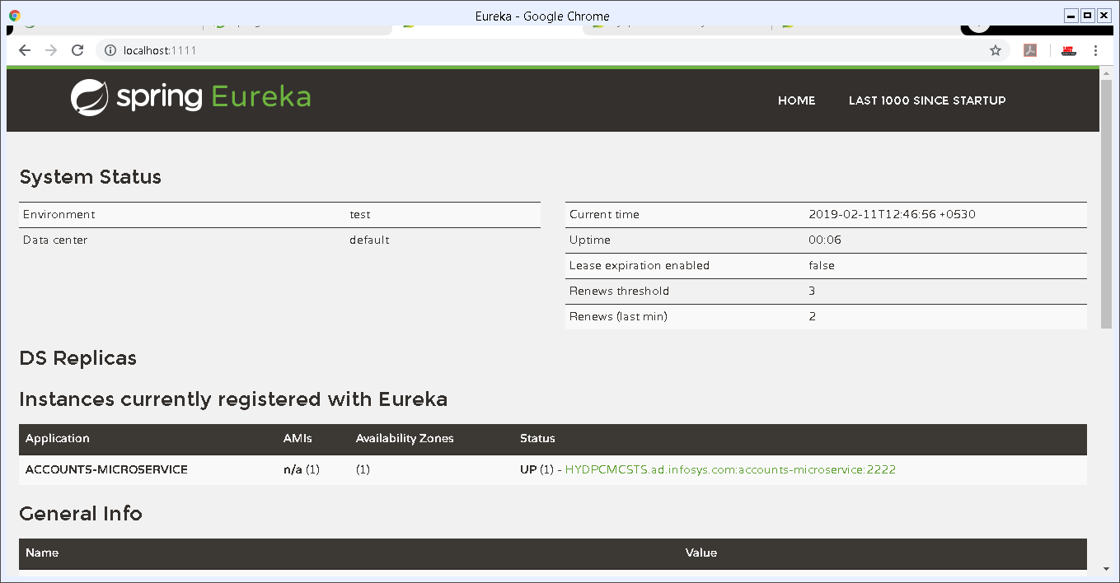

3. Webclient Mroservice server – User will ask for Specific Account details with AccNo
https://github.com/dineshonjava/webclient-microservice-server
Create users to find the Producer Service registered with Discovery Service by adding @EnableDiscoveryClient. This annotation also allows us to query Discovery server to find microservices

@SpringBootApplication
@EnableDiscoveryClient
public class WebclientMicroserviceServerApplication {

public static final String ACCOUNTS_SERVICE_URL = "http://ACCOUNTS-MICROSERVICE";

public static void main(String[] args) {
SpringApplication.run(WebclientMicroserviceServerApplication.class, args);
}

@Bean
@LoadBalanced
public RestTemplate restTemplate() {
return new RestTemplate();
}
@Bean
public AccountRepository accountRepository(){
return new RemoteAccountRepository(ACCOUNTS_SERVICE_URL);
}
}

Now run this consumer service application as Spring Boot application and after few seconds refresh the browser to the home page of Eureka Discovery Server at http://localhost:1111
Now one more Service registered to the Eureka registered instances with Service Name “ACCOUNTS-WEB” as below
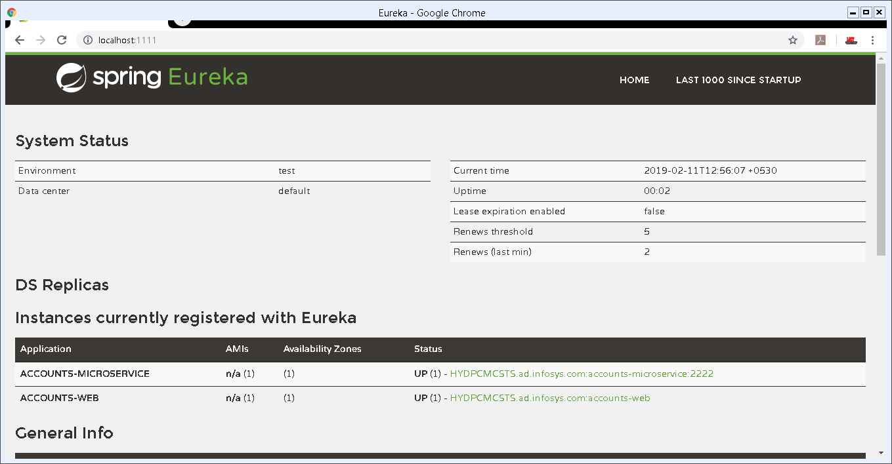

4.Access URL Through Web Application
We already created a Web Application in Webclient Mroservice server to call registred Discovery Server URLs.which is running on
http://localhost:8080/
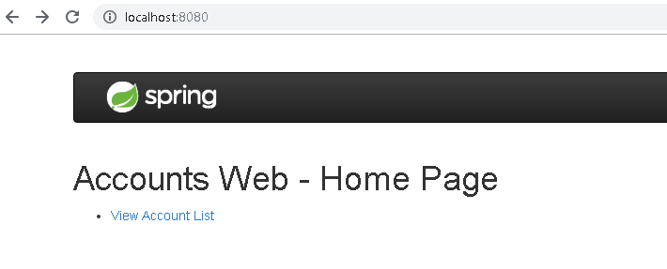
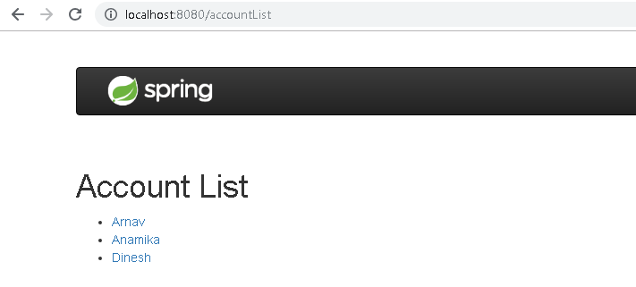
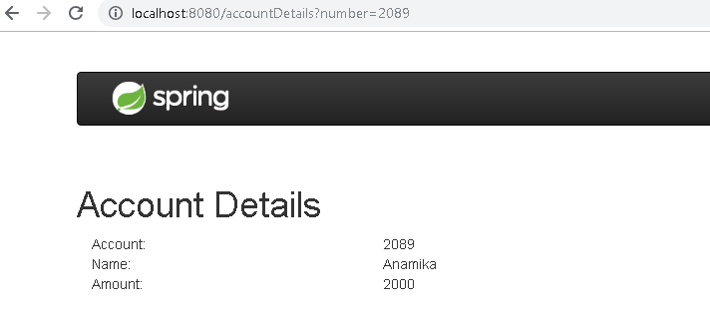
https://www.dineshonjava.com/microservices-with-spring-boot/
https://spring.io/blog/2015/07/14/microservices-with-spring

Reactive JavaRx
- Reactive comes from the word react, which means to react to changes in the state instead of actually doing the state change.
- The reactive model listens to changes in the event and runs the relevant code accordingly.
- observer/subscriber attached listening to the stream would receive the data.

The basic building blocks of RxJava are:
- Observables: That emits data streams
- Observers and Subscribers: That consume the data stream. The only difference between an Observer and a Subscriber is that a Subscriber class has the methods to unsubscribe/resubscribe independently without the need of the observerable methods.
- Operators: That transform the data stream
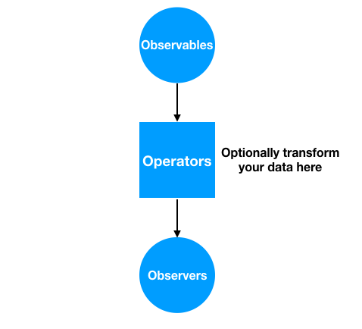
https://cdn.journaldev.com/wp-content/uploads/2018/02/rxjava-basics-flow.png

SpringBoot – Reactive Programming
Spring WebFlux framework is part of Spring 5 and provides reactive programming support for web applications
Spring WebFlux internally uses Project Reactor and its publisher implementations – Flux and Mono.
<dependency>
<groupId>org.springframework.boot</groupId>
<artifactId>spring-boot-starter-webflux</artifactId>
<version>2.0.3.RELEASE</version>
</dependency>

We’ll now build a very simple Reactive REST EmployeeManagement application – using Spring WebFlux:
- We’ll use a simple domain model – Employee with an id and a name field
- We’ll build REST APIs for publishing and retrieve Single as well as Collection Employeeresources using RestController and WebClient
- And we will also be creating a secured reactive endpoint using WebFlux and Spring Security

@RestController
@RequestMapping("/employees")
public class EmployeeReactiveController {

private final EmployeeRepository employeeRepository;

@GetMapping("/{id}")
private Mono<Employee> getEmployeeById(@PathVariable String id) {
return employeeRepository.findEmployeeById(id);
}

@GetMapping
private Flux<Employee> getAllEmployees() {
return employeeRepository.findAllEmployees();
}

}

Reactive Web Client
WebClient introduced in Spring 5 is a non-blocking client with support for Reactive Streams.
On the client side, we use WebClient to retrieve data from our endpoints created inEmployeeController.
public class EmployeeWebClient {

WebClient client = WebClient.create("http://localhost:8080");

Mono<Employee> employeeMono = client.get()
.uri("/employees/{id}", "1")
.retrieve()
.bodyToMono(Employee.class);

employeeMono.subscribe(System.out::println);

Flux<Employee> employeeFlux = client.get()
.uri("/employees")
.retrieve()
.bodyToFlux(Employee.class);

employeeFlux.subscribe(System.out::println);

}

https://www.baeldung.com/spring-webflux
https://www.journaldev.com/20763/spring-webflux-reactive-programming

AngularJs(Angular 1) vs Angular (Angular 2)
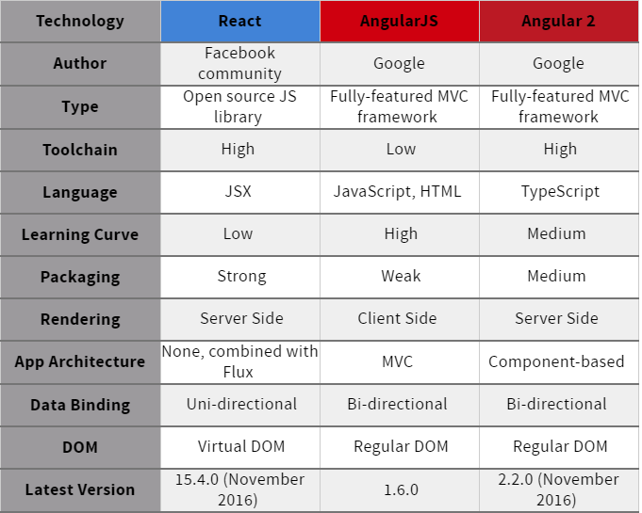
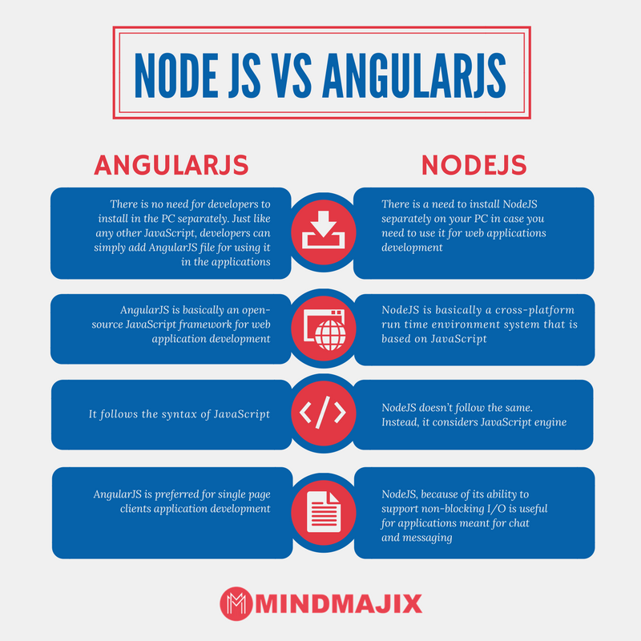

What exactly node.js is?
Is it a web server or a programming language for server-side scripts?
- So here’s how it is, how it’s always been: a browser sends a request to a website. The site’s server receives the request, tracks down the requested file, performs any database queries as needed, and sends a response to the browser. In traditional web servers, such as Apache, each request causes the server to create a new system process to handle that request
- Now think about what that means for a traditional web server like Apache. For each and every user connected to the site, your server has to keep a connection open. Each connection requires a process, and each of those processes will spend most of its time either sitting idle (consuming memory) or waiting on a database query to complete. This means that it’s hard to scale up to high numbers of connections without grinding to a near halt and using up all your resources.

- So what’s the solution? Here’s where some of that jargon from before comes into play: specifically non-blocking and event-driven

- Think of a non-blocking server as a loop: it just keeps going round and round. A request comes in, the loop grabs it, passes it along to some other process (like a database query), sets up a callback, and keeps going round, ready for the next request. It doesn’t just sit there, waiting for the database to come back with the requested info.

- If the database query comes back — fine, we’ll deal with that the same way: throw a response back to the client and keep looping around. There’s theoretically no limit on how many database queries you can be waiting on, or how many clients have open requests, because you’re not spending any time waiting for them. You deal with them all in their own time

- event-driven means: the server only reacts when an event occurs. That could be a request, a file being loaded, or a query being executed — it really doesn’t matter.

How to host node.js applications?
You need to Host AWS or Google Cloud or any other cloud platform because it needs Node.js to be installed.

Npm, bower packges
Let’s understand by Example
I used the complete MEAN stack for this series
MEAN is a set of Open Source components that together, provide an end-to-end framework for building dynamic web applications;
- MongoDB : Document database – used by your back-end application to store its data as JSON (JavaScript Object Notation) documents
- Express (sometimes referred to as Express.js): Back-end web application framework running on top of Node.js
- Angular (formerly Angular.js): Front-end web app framework; runs your JavaScript code in the user’s browser, allowing your application UI to be dynamic
- Node.js : JavaScript runtime environment – lets you implement your application back-end in JavaScript
1.create package.json to install some Node packages.(like maven, here we can see express.js dependency)
//package.json
{
"name": "node-rest-auth",
"main": "server.js",
"dependencies": {
"bcrypt": "^0.8.5",
"body-parser": "~1.9.2",
"express": "~4.9.8",
"jwt-simple": "^0.3.1",
"mongoose": "~4.2.4",
"morgan": "~1.5.0",
"passport": "^0.3.0",
"passport-jwt": "^1.2.1"
}
}

To install pacakges Run
npm install
This will install all our modules to node_modules/.
We can also install one by one without package.json as below, it will get latest version of it
npm install mongojs
npm install express

2.create server.js, here we import all the needed elements and create our server with url localhost:9090
var express = require('express');
var app = express();
var bodyParser = require('body-parser');
var morgan = require('morgan');
var mongoose = require('mongoose');
var passport = require('passport');
var config = require('./config/database'); // get db config file
var User = require('./app/models/user'); // get the mongoose model
var port = process.env.PORT || 9090;
var jwt = require('jwt-simple');

// get our request parameters
app.use(bodyParser.urlencoded({ extended: false }));
app.use(bodyParser.json());

// log to console
app.use(morgan('dev'));

// Use the passport package in our application
app.use(passport.initialize());

// demo Route (GET http://localhost:9090)
app.get('/', function(req, res) {
res.send('Hello! The API is at http://localhost:' + port + '/api');
});

// Start the server
app.listen(port);
console.log('There will be dragons: http://localhost:' + port);

3.config/database.js
module.exports = {
'secret': 'devdacticIsAwesome',
'database': 'mongodb://localhost/node-rest-auth'
};

4. user model for our user authentication
//app/models/user.js
var mongoose = require('mongoose');
var Schema = mongoose.Schema;
var bcrypt = require('bcrypt');

// Thanks to http://blog.matoski.com/articles/jwt-express-node-mongoose/

// set up a mongoose model
var UserSchema = new Schema({
name: {
type: String,
unique: true,
required: true
},
password: {
type: String,
required: true
}
});

UserSchema.pre('save', function (next) {
var user = this;
if (this.isModified('password') || this.isNew) {
bcrypt.genSalt(10, function (err, salt) {
if (err) {
return next(err);
}
bcrypt.hash(user.password, salt, function (err, hash) {
if (err) {
return next(err);
}
user.password = hash;
next();
});
});
} else {
return next();
}
});

UserSchema.methods.comparePassword = function (passw, cb) {
bcrypt.compare(passw, this.password, function (err, isMatch) {
if (err) {
return cb(err);
}
cb(null, isMatch);
});
};

module.exports = mongoose.model('User', UserSchema);

Now the basics are set up, and you can start our server from now on just with
node server.js
https://devdactic.com/restful-api-user-authentication-1/

Now NPM vs Bower
Npm and Bower are both dependency management tools. But the main difference between both is
- npm is used for installing Node js modules
- bower is used for managing front end components like html, css, js etc
running bower install will fetch the package and put it in /vendor directory,
running npm install it will fetch it and put it into /node_modules directory.
Grunt is quite different from Npm and Bower. Grunt is a javascript task runner tool. You can do a lot of things using grunt which you had to do manually otherwise
There are grunt plugins for compilation, uglifying your javascript, copy files/folders, minifying javascript etc.

References
OnlineHTML - https://www.froala.com/online-html-editor

